H-1B
Performance Reporting Toolkit and
Workforce Integrated Performance System (WIPS)
User Technical Guide

Performance Reporting Technical Assistance for:
- Scaling Apprenticeship Through Sector-Based Strategies
- Apprenticeships: Closing the Skills Gap

Prepared by:
United States Department of Labor
Employment and Training Administration
Office of Workforce Investment
Division of Strategic Investments

VERSION 1.0 – August 2021

Table of Contents
About this Guide……………………………………………………………………………………………………………………………3

Part I. Participant Data Collection……………………………………………………………5
Determining Participant Eligibility………………………………………………………………………………………….5
Participant Intake…………………………………………………………………………………………………………………..5
Intake Forms………………………………………………………………………………………………………………………….5
Converting Data Elements into Enrollment Questions…………………………………………………………...6
Collecting Personally Identifiable Information (PII)…………………………………………………………………7
Social Security Numbers…………………………………………………………………………………………………………7

Part II. Data and Performance Management…………………………………………..9
H-1B Data Elements…………………………………………………………………………………………………………….…9
Ongoing Case Management…………………………………………………………………………………………………10
Collecting and Tracking Participant Data………………………………………………………………………………10
Documenting Data and Validating Reports…………………………………………………………………………..11
Securing Personally Identifiable Information………………………………………………………………………..11
Uploading Data Files…………………………………………………………………………………………………………….11
Certifying Data Files……………………………………………………………………………………………………………..12
Establishing Staff Roles and Responsibilities…………………………………………………………………………12

Part III. WIPS Technical Guide to Quarterly Progress Reporting………………13
Accessing WIPS and WIPS Access Levels……………………………..………………………………………………..13
Password Reset…………………………………………………………………………………………………………………….14
Preparing Data Files………………………………………………………………………………………………………………15
Successfully Uploading a Data File………………………………………………………………………………………..17
Resolving Data File Errors……………………………………………………………………………………………………..21
Saving a Copy of your QPR…………………………………………………………………………………………………….22
Certifying a QPR form……………………………………………………………………………………………………………22
Certifying a QNR form…………………………………………………………………………………………………………..23
Transmitting PII…………………………………………………………………………………………………………………….23
Guidance for Authorized Representatives on Multiple H-1B Grants……………………………………..23
How to Get WIPS Technical Assistance…………………………………………………………………………………24

Appendix A: WIPS H-1B User Role Policy………………………………………………………………………….25
Appendix B: WIPS TIPS for Common Errors………………………………………………………………………26
Appendix C: QNR Special Instructions for Reporting On Expanding Apprenticeship Program Outputs……………………………………………………………………………………………………………………………28

About this Guide
https://wdr.doleta.gov/directives/attach/TEGL/TEGL_14-18.pdf
H-1B grantees are required to submit Quarterly Progress Reports to DOL/ETA each reporting quarter, which includes an H-1B Quarterly Performance Report (QPR) and a Quarterly Narrative Report (QNR).

This guide is offered as a supplement to H-1B Grants Scaling Apprenticeship and Apprenticeships: Closing the Skills Gap Performance Reporting Handbook and TEGL 14-18: Aligning Performance Accountability Reporting, Definitions, and Policies Across Workforce Employment and Training Programs Administered by the U.S. Department of Labor (DOL), and is designed to support H-1B Scaling Apprenticeship (SA) and Apprenticeships: Closing the Skills Gap grantees in preparing and submitting their Quarterly Progress Reports to the Department of Labor (DOL), Employment and Training Administration (ETA).
ETA wants to ensure your data collection, tracking, and reporting efforts are as seamless and accurate as possible with minimal burden. Ultimately, we want those efforts to reflect the great work and impact your program is having on the workforce. There are a few things grantees must do to accurately and effectively report on participants:
- Determine participant eligibility
- Collect participant data
- Track participant data
- Update participant data, as needed
- Report participant data

We have provided information on these tasks in three sections below:

- Part I. Participant Data Collection, which includes general information on what information to collect from grant participants and tips on how to collect it in order to meet grant requirements.

- Part II. Data and Performance Management, which provides some best practices for developing performance collection, tracking and reporting procedures for your grant and structuring case management.

- Part III. WIPS Technical Guide to Quarterly Progress Reporting, which provides the technical information necessary on how to access the reporting system and the Workforce Integrated Performance System (WIPS) requirements for successfully submitting reports each quarter.

This technical assistance tool is designed specifically for H-1B Grants Scaling Apprenticeship and Apprenticeships: Closing the Skills Gap grant staff such as data entry and IT personnel, case managers, program managers, and directors, as well as training and supportive service partners, who are responsible for tracking participant records, creating grantee data files, uploading data files, and submitting quarterly progress reports.

Below is a Performance Reporting Checklist to help you ensure you have everything you need for successful performance reporting.

Performance Reporting Checklist
H-1B Funding Opportunity Announcement (FOA) | Your Program’s Statement of Work (SOW)
Are you aware of?  - Allowable Grant Activities  - Allowable Training and Services  - Participants Eligible to Receive Training | Are you aware of?  - Program Design  - Target Population  - Training and Services  - Target Performance Outcomes
— PERFORMANCE REPORTING CHECKLIST —
- What documents do I need to review?
    - H-1B FOA
    - TEGL 14-18
    - TEGL 23-19
    - My grant program’s Statement of Work
    - My target performance outcomes
- How do I learn about the performance reporting requirements for this grant?
    - Review the H-1B Grants Scaling Apprenticeship and Apprenticeships: Closing the Skills Gap Performance Reporting Handbook
- What are the H-1B PIRL Data Elements?
    - Review the Amended 2021 PIRL for H-1B Grants
    - See Sample Data Files and Participant Records
- Where do I go to find more information?
    - Shared performance resources are posted online at the respective grant program resource page
- Who do I contact if I have a question?
    - Contact the grant program team using the email address for performance-related questions at ScalingApprenticeship@dol.gov or ClosingtheSkillsGap@dol.gov, with a cc: to your Federal Project Officer (FPO)
    - For all other grant-related matters (non-performance reporting questions) your first point of contact should always be your FPO

Part I. Participant Data Collection
This section includes general information on what information to collect from grant participants and tips on how to collect it in order to meet grant requirements.

Determining Participant Eligibility

Before collecting participant data on an individual, first establish whether an individual is eligible for your H-1B training program and activities. As part of your process to determine participant eligibility, some sample questions might include:

- Is the individual eligible based on the grant’s H-1B FOA?
- Is the individual eligible based on the grant Statement of Work (SOW) that was submitted to DOL?

Gathering the information needed to inform the H-1B data elements should be an integral part of your participant on-boarding process (including: assessment, intake, and orientation).

Best Practice: Tracking this information in an electronic format will allow grantees, employer partners, training providers and other stakeholders the ability to track outcomes in a systematic way that will help ensure consistency and accuracy.

Participant Intake

As an individual is determined eligible for your specific program activities, you will need an intake process for assessing and collecting information from this individual. An intake process could entail processes such as:

- Completing intake forms
- Conducting an intake interview
- Hosting intake sessions and/or other orientation activities

Guidance provided by ETA on H-1B grants performance reporting can be used by grantees to explain the need for collecting participant information. Providing participants an explanation for why the information is being collected may increase the likelihood that you will get this information for reporting purposes.

Intake Forms

Your program’s participant intake and/or enrollment form(s) should include questions that help inform all relevant initial data required for H-1B performance reporting; this might include date of entry into the program, age of the participant, employment status at program entry, or other relevant information.

The H-1B data elements have specific definitions that you can use as questions to develop your intake and enrollment forms. Some of these questions can be transferred on to a form to ensure they are 1) being asked in a way that explains the purpose, and 2) ensures the questions are consistent with how DOL will need to report outcomes based on the questions asked.

Sample Participant Intake Form
H-1B Grant Program
Grant Name: Case Manager:

PARTICIPANT CONTACT INFORMATION
First Name:
Middle Name: Last Name:
Address:
Phone Number: Email Address:

PARTICIPANT DEMOGRAPHICS
* Social Security Number:
Date of Birth: Gender: (Male) (Female)
Do you self-identify as a person of Cuban, Mexican, Puerto Rican, South or Central American, or other Spanish culture in origin, regardless of race? YES/NO
Do you self-identify as a person having origins in any of the original peoples of North America and South America (including Central America), and who maintains cultural identification through tribal affiliation or community recognition? YES/NO

Converting Data Elements into Enrollment Questions

An H-1B data element (DE) is a unique identifier that enables ETA to collect information required to assess the performance of federal investments for various training and employment programs. H-1B DEs are defined in the 2021 PIRL for H1B Grants Updated August 2021. These DEs are used to record participant-level data, track participant outcomes used for Quarterly Progress Reports, and to assess the grantee’s internal progress. (See Part II. Data and Performance Management for more information)

The table below provides an example of how these DEs could be converted into questions to include on an intake/enrollment form.

Converting Data Elements into Enrollment Questions
DE # | Data Element | Description | Sample Intake Form Question
210 | Ethnicity Hispanic/ Latino | Record 1 if the participant indicates that he/she is a person of Cuban, Mexican, Puerto Rican, South or Central American, or other Spanish culture in origin, regardless of race. Record 0 if the participant indicates that he/she does not meet any of these conditions. Record 9 if the participant did not self-identify his/her ethnicity. | Question One: Do you self-identify as a person of Cuban, Mexican, Puerto Rican, South or Central American, or other Spanish culture in origin, regardless of race?  YES/NO
211 | American Indian or Alaska Native | Record 1 if the participant indicates that he/she is a member of an Indian tribe, band, nation, or other organized group or community, including any Alaska Native village or regional or village corporation as defined in or established pursuant to the Alaska Native Claims Settlement Act (85 Stat. 688) [43 U.S.C. 1601 et seq.], which is recognized as eligible for the special programs and services provided by the United States to Indians because of their status as Indians. Record 0 if the participant indicates that he/she does not meet any of these conditions. Record 9 if the participant did not self-identify his/her race. | Question Two: Do you self-identify as a person having origins in any of the original peoples of North America and South America (including Central America), and who maintains cultural identification through tribal affiliation or community recognition? YES/NO

Collecting Personally Identifiable Information (PII)

Grantees may possess large quantities of PII for program participants. This information is generally found in personnel files, participant data sets, performance reports, program evaluations, grant and contract files, and other sources. The Office of Management and Budget (OMB) defines PII as information that can be used to distinguish or trace an individual’s identity, either alone or when combined with other personal or identifying information that is linked or linkable to a specific individual. Grantees are required to protect PII when transmitting information, but are also required to protect PII and sensitive information when collecting, storing, and/or disposing of information as well (See Part II. Data and Performance Management, Securing Personal Identifiable Information for more information)

Social Security Numbers

All H-1B grantees are asked to collect Social Security Numbers (SSNs) for all participants served with grant funds and report outcomes to ETA. However, while H-1B grantees are required to request participants’ SSNs, participants cannot be denied services if they choose to not disclose an SSN. Grantees should also ensure that when they are collecting this information from participants, they inform the participants of the reason for requesting SSNs, in accordance with the American Competitiveness and Workforce Improvement Act.

Grantees have reported that employer partners and training providers can be sensitive to the collection of SSNs and forms that included questions identifying race and/or ethnicity. Participant intake forms should include disclaimer language around the collection of SSNs.

Sample Disclaimer Language on the Collection of Personally Identifiable Information (PII):
Grantees may use the following sample text to inform participants how PII is being protected and why SSNs are being collected:

*This project was funded by a grant awarded under the H-1B grants by the U.S. Department of Labor's Employment and Training Administration. The collection of this information helps to track the long-term success of this training program. Your personal information is kept confidential and secure and will not be shared with any outside agencies other than those involved with the support or oversight of the H-1B grant received by Sample Community College and issued by the U.S. Department of Labor. Your information will never be sold or shared with third party agencies through your participation in grant supported training activities. Please direct any additional questions concerning the use of your personal information to Jane Green, Program Director at 856-691-XXXX.
In addition to requesting a range of information from project participants, including demographic information, the use of your Social Security Number is also requested in order to access wage and employment information through state databases. Although you cannot be denied service for failure to provide your Social Security Number, we strongly encourage you to do so in order to enable the project to quantify specific employment-related outcomes.

ETA, on behalf of the grantees, will work with its State partners to match participant SSNs with employment data available from State Unemployment Insurance (UI) and other administrative wage records (e.g., Federal and Military employment). This matching procedure is necessary in order for ETA to collect consistent and reliable aggregate outcome information for each grantee. ETA calculates a set of Workforce Innovation and Opportunity Act Indicators of Performance that include entry into employment, employment retention, and median earnings.

The H-1B Scaling Apprenticeship and Apprenticeships: Closing the Skills Gap Performance Reporting Handbook provides more information on the collection of SSNs to help you, your service and training providers, and employer partners during this process.

Part II. Data and Performance Management
This section provides some best practices for developing performance collection, tracking and reporting procedures for your grant and structuring case management.

H-1B Data Elements

As referenced in Part I. Participant Data Collection, an H-1B data element (DE) is a unique identifier that enables ETA to collect information required to assess the performance of federal investments for various training and employment programs, and the H-1B DEs are defined in the 2021 PIRL for H1B Grants (Updated August 2021) (2021 PIRL).

The 2021 PIRL includes five key sections: Individual Information, Program Participation Information, Services and Activities, Program Outcomes Information, and H-1B. Grantees are required to collect the data elements specified in these sections for H-1B grant performance reporting purposes.
RESOURCE ALERT!
H-1B SA PIRL Data Elements

H-1B PIRL Data Elements Sample
DATA ELEMENT NO. | DATA ELEMENT NAME | DATA TYPE/ FIELD LENGTH | DATA ELEMENT DEFINITIONS/INSTRUCTIONS | CODE VALUE | H-1B PROGRAM REQUIREMENTS¹
1307 | Training Completed #1 | IN 1 | Record 1 if the participant completed approved training  Record 0 if the participant did not complete training (withdrew)  Leave blank if the participant did not receive a first training or this data element does not apply to the participant. | 1 = Yes  0 = No (withdrew) | R  [required]
1308 | Date Completed or Withdrew from Training #1 | DT 8 | Record the date when the participant completed training or withdrew permanently from training. If multiple training services were recorded, record the most recent date on which the participant completed training.  Leave blank if the participant did not receive a first training or this data element does not apply to the participant. | YYYYMMDD | R  [required]

Each data element has a:
- Data number and name
- Data type
- Data definition and instruction
- Code value

Please review the 2021 PIRL to understand what information to collect in order to report on all of the data elements and correct code values for your participants. Part III of this guide explains how WIPS will check your data file for errors before your file will be accepted.

Case Management

Once a participant is determined eligible for your grant’s H-1B program, it is essential to maintain case files for each participant using your internal database system.

- Your case management system should include a method for tracking all data elements upon intake and throughout the period a participant is provided grant-funded services.
- In some cases, training providers may use your system as a mechanism for tracking participant information in an electronic format that can be easily accessible to you, the grantee.

HOT TIPS

- Make sure your system includes EVERY H-1B required data element as a data field entry for each participant record.
- Make sure you have a record-keeping system for documenting all of the data elements you enter into WIPS.
- A participant record should have a corresponding code value for most data elements. In some cases, leaving the data field blank is an option if the data element does not apply to the participant.
- Ensure any entities collecting participant data such as sub-grantees and contractors are collecting the same required participant information. The information collected should be based on the data elements provided in the H-1B Scaling Apprenticeship and Apprenticeships: Closing the Skills Gap Performance Reporting Handbook.
Collecting and Tracking Participant Data

Collecting and tracking participant data will vary depending on the service providers for your grant. Although training providers, employers, workforce agencies, or other types of service providers won’t access WIPS directly, it’s important to establish communication protocol between the Grant Program Manager/Director and those collecting data directly from participants. Participant-level data will always need to be stored and transmitted securely.

HOT TIPS
Here are some tips to help improve the data collection process between program grantees, employer partners and education and training providers:
- Develop an electronic case management system that can be transferable between appropriate program partners in order to better assist the development and submission of quarterly reports to DOL.
- Ensure all data elements are reviewed and definitions are understood by all partners before deciding how to answer the data element code values for a participant.
- Ensure that all relevant program partners and training participants understand why certain information is collected, where it is sent and for what purpose.
For example, often training participants are handed a paper form to fill out basic details, which is handed back to the training provider with minimal face-to-face interaction. Unless there is an intermediary, like a case manager, the need for this information may not fully explain or understood.
- Add disclaimer language and guidance during the enrollment process so participants will understand why certain information is being collected on them.
- Ensure relevant dates that inform certain data elements are recorded.
Documenting Data and Validating Reports

Grantees should keep records to verify the data they report on participants. TEGL 23-19: Guidance for Validating Required Performance Data Submitted by Grant Recipients of U.S. Department of Labor (DOL) Workforce Programs provides information on what documentation is sufficient to validate each data element. Grantees should speak with their FPOs about what information should be included in participant case files to ensure they are meeting documentation requirements. In addition, grantees should review aggregated QPRs each quarter for accuracy to check ensure DOL’s official data matches their own records, and correct and make updates to the data file in subsequent quarters as needed.

Securing Personally Identifiable Information

Grantees must secure Personally Identifiable Information (PII). When grantees collect this information from participants, grantee staff should ensure that that participants are informed of why they are being asked to provide their Social Security Number (SSN). Guidance regarding their handling and protection of PII is provided at TEGL 39-11: Guidance on the Handling and Protection of Personally Identifiable Information (PII) and in the H-1B Scaling Apprenticeship and Apprenticeships: Closing the Skills Gap Performance Reporting Handbook.

Uploading Data Files

Once necessary data is collected from participants, grantees will need to ensure that data is saved as one of the appropriate file types (.csv file extensions) before being uploaded into WIPS (See Part III. WIPS Technical Guide for Quarterly Progress Reporting). If there is a change in grant staff responsible for reporting, please ensure that the new staff is familiar with this process and notify DOL through your grant program mailbox with any grant staff changes.

Certifying Reports

Only the Authorized Representative for your grant is permitted to certify quarterly progress reports. See Part III. WIPS Technical Guide to Quarterly Progress Reporting for more information on WIPS account access.

Establishing Staff Roles and Responsibilities

An essential part of efficient grants management is to establish roles and responsibilities for your staff. This chart provides recommendations on how to establish staff roles and responsibilities for each of the tasks above, as well as accessing and utilizing WIPS. As previously described in the introduction, WIPS is the performance reporting system H-1B grantees use to submit their quarterly progress reports.

Staff Roles and Responsibilities for Accessing WIPS
Staff Role | Action
- Case Manager, Program Coordinators, Training Partners,  Service Providers, Employers | - Collect participant data and data from partners  - Track participant data using internal Management Information Systems  - Document data and validate reports
- Authorized Representative, Program Director | - Secure Personally Identifiable Information
- Program Director or Manager,  Data Managers, IT Staff | - Upload data files into WIPS  - Resolve data file errors  - Troubleshoot issues in WIPS
- Authorized Representative | - Certify Quarterly Performance Report (QPR) form

Part III. WIPS Technical Guide for Quarterly Progress Reporting

This section provides the technical information necessary on how to access the reporting system and WIPS requirements for successfully submitting reports each quarter.

Accessing WIPS and WIPS Access Levels

There are two user access levels in WIPS for which accounts are granted by ETA: a Level 1 Certification Account and a Level 2 Upload Account.

All grantees are automatically issued a Level 1 Certification Account upon grant award.

You may optionally request one Level 2 Upload Account. This user account can perform WIPS functions that support your grant’s Quarterly Progress Report completion for both the QNR and the QPR, including entering information into the reporting system, file upload, reviewing errors, and viewing reports.

Please note that Level 2 Upload Account users cannot certify neither the QNR nor the QPR report, as only the Authorized Representative can certify that the reports are accurate for a quarter.

Requesting a Level 2 Upload Account
To request an optional Level 2 Upload Account, the Authorized Representative on record must send an email to the grant program mailbox with the following contact information for the designated Level 2 Upload Account user at your grant:

- Contact Full Name
- Contact Email Address

We recognize that you may have multiple staff members that support your DOL grant program; however, the only credentials that can be used for your grant program are the Level 1 Certification Account and the Level 2 Upload Account. We defer to the grantee’s policies and procedures on how this information is shared amongst your team.

Changing Access for the Level 1 Certification Account
As only the Level 1 Certification Account has the ability to certify grant reports, only the Authorized Representative on file can be issued a Level 1 Certification Account.

Any Authorized Representative change needs to go through the grant modification process, assisted by your FPO. The modification, signed by the Grant Officer, is the formal approval of the Authorized Representative change.

We will not be able to issue Level 1 access credentials to individuals that are not formally recognized as the Authorized Representative for the grant.

For a complete description of DOL’s policy on WIPS H-1B access accounts, please see Appendix A.

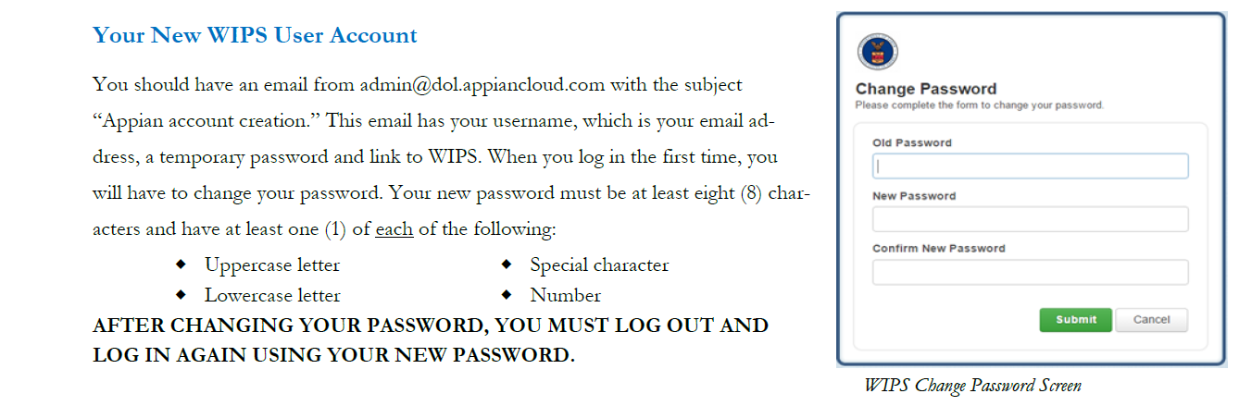

- In some cases, your organization’s internal firewalls may block the WIPS access credential email from arriving to the Authorized Representative.
  - Please make admin@dol.appiancloud.com a preferred email address so that it is not rejected by your organization’s internal firewalls.

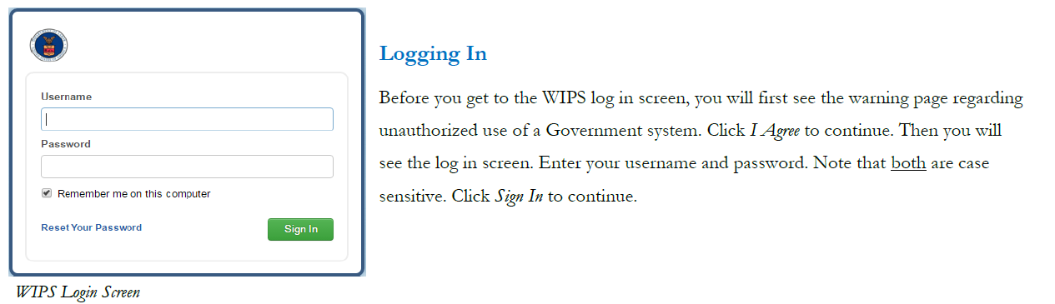

Password Reset

In order to reset your password, use the WIPS Technical Assistance Request form and include your name and email address and choose “Password Reset” from the “Issue Classification” dropdown box.

Make sure all the necessary fields are filled out, and you should receive an email immediately letting you know that they received the request and again when they have completed the request.

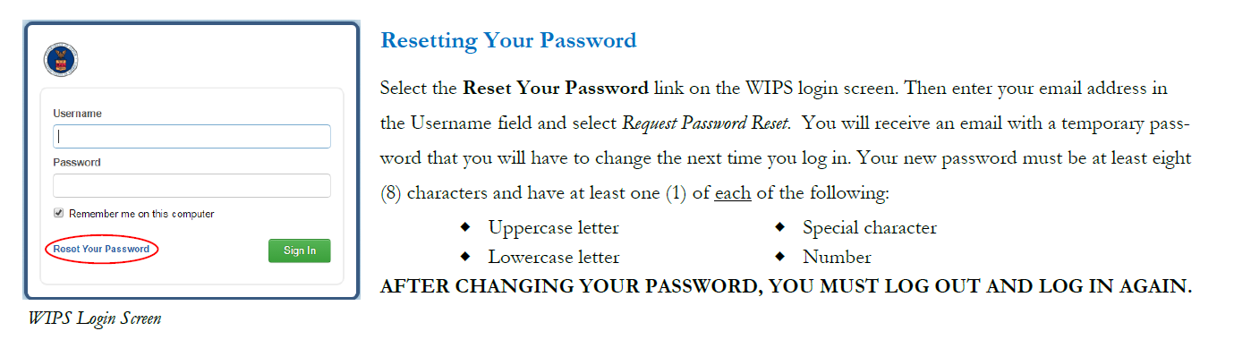

- If you receive a message that the system has sent you new login credentials and you do not see it in your mailbox, please check your Spam folder. If you cannot find it, fill out this form to escalate the situation: https://www.doleta.gov/performance/wips/WIPS_Technical_Assistance_Request.cfm

- When your password is reset, you will receive a message from “BPMS – U.S. Department of Labor Password Change” that will be sent from admin@appiancloud.com.

Preparing Data Files

Each quarter, H-1B grantees will upload a data file that includes the approved H-1B Participant Individual Record Layout (PIRL) data elements. PIRL data elements are the required pieces of information that must be reported for each participant served in your program. Data files contain code values for each PIRL data element for each participant.

Review Tab 2 of the 2021 PIRL for a description of all 90 data elements and the code values corresponding to each.

Sample Case Management and Data File

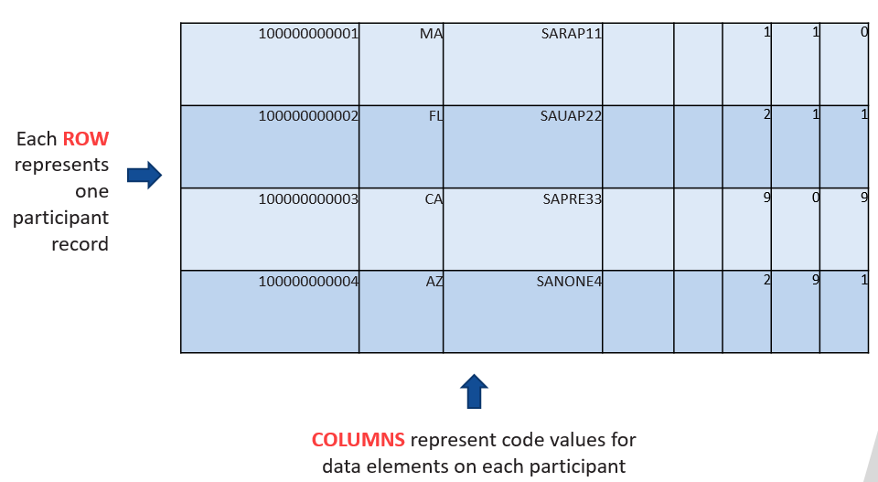
Download Performance Resources:

- DOL Participant Individual Record Layout (PIRL)

- Sample Case Management File

- Sample Data File

- Performance Reporting Toolkit

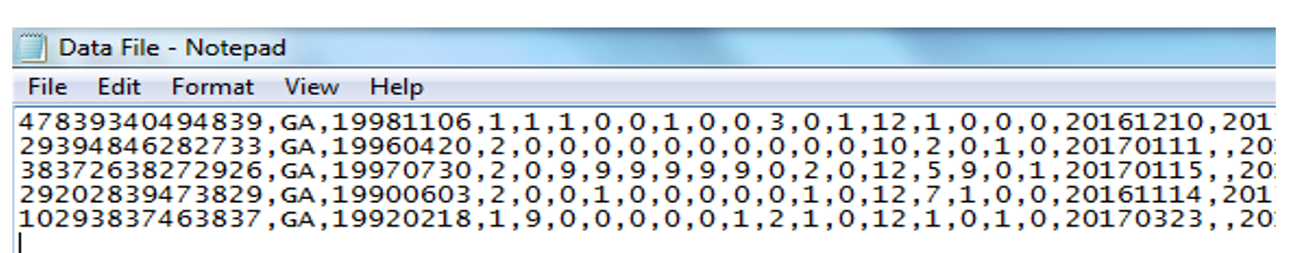

IMPORTANT NOTES ABOUT DATA FILE FORMAT REQUIREMENTS

- Data file must be in .csv or .txt format.
- Data file must include a column for each of the data elements in the schema.
- Data files cannot contain:
  - Participant names
  - Data element headers
  - Additional blank rows
  - Blank entries when code values are required
  - Null values instead of a blank or space
- Every data element must have a data field entry. Although for most data elements, a participant will have a corresponding code value, in some cases, leaving the data element blank is appropriate when the data element does not apply. The PIRL resources linked above will help determine the conditions when data elements can or should be left blank.

Grantees may use existing resources or develop their own internal Management Information System (MIS), but that system must be able to save or export participant records in .csv and or .txt format.

In addition, if grantees are receiving records from multiple partners, they must be generated and uploaded as one .csv or .txt for the grant.

Please see Appendix B: WIPS TIPS! to learn how to resolve the most common data file errors.

Successfully Uploading a Data File

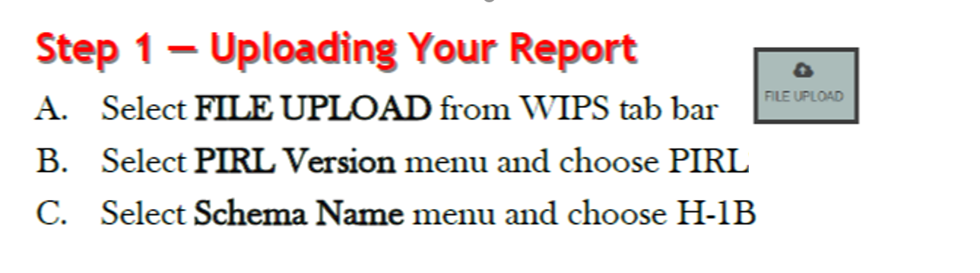

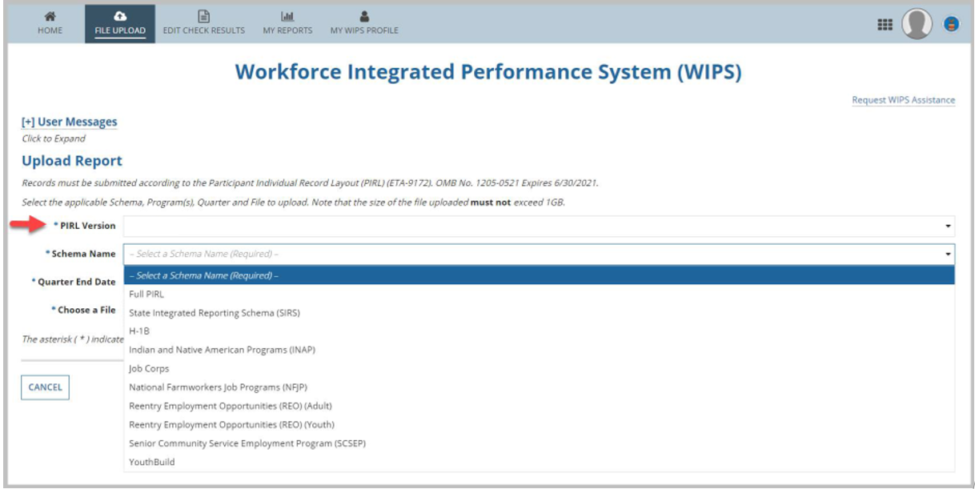

Note that WIPS will generate an error during the submission and edit check process if an incorrect PIRL Version or Schema Name is selected.

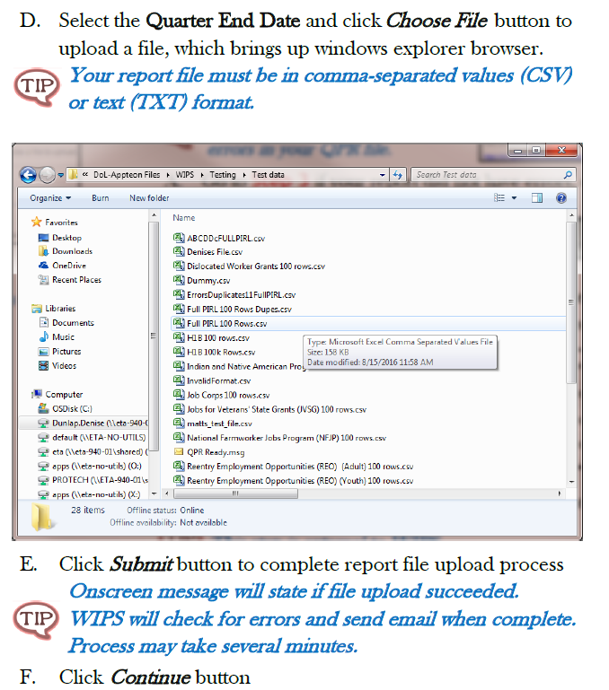

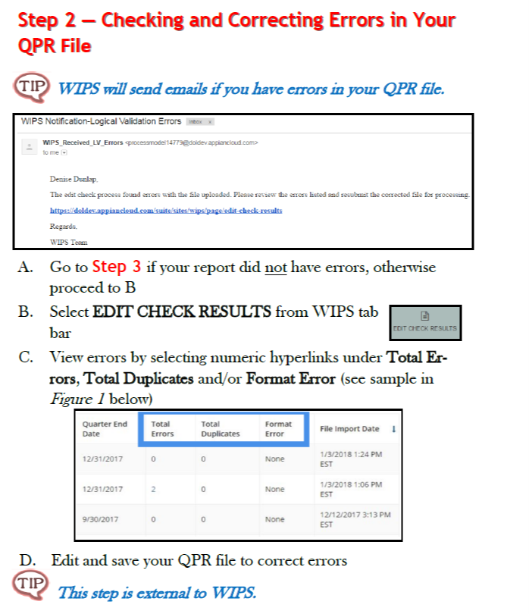

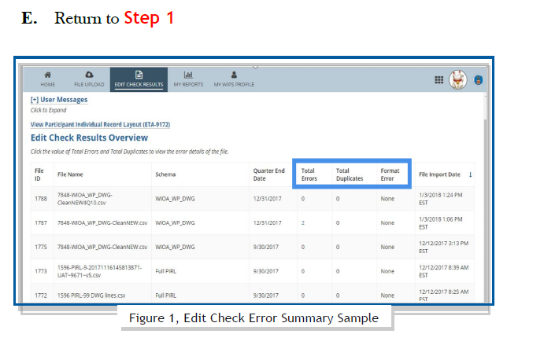

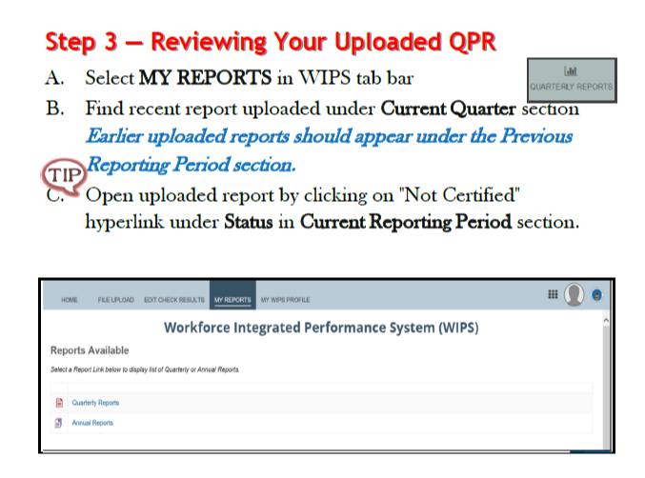

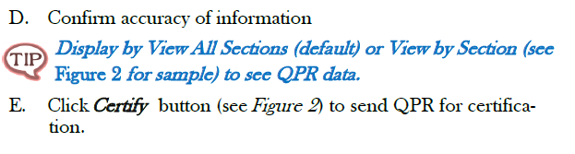

Please see Appendix B: WIPS TIPS! to learn how to resolve the most common data file errors.
Resolving Data File Errors

When you submit your data file, WIPS executes four data validation checks in three stages. Each stage must be passed before WIPS can then progress to the next stage of edit checks. You can find out if you have any errors and what type by reviewing the “Edit Check Results” tab.

When all three stages have been passed, grantees can then review the QPR and certify and submit the report.

The Three Stages of WIPS Data Validation Checks

Stage 1
When you first submit your data file, WIPS will execute the first two types of edit checks simultaneously: FORMATTING CHECK ERRORS and VALID VALUES ERRORS. This means WIPS will check to ensure that your data file itself is in the proper format and that the values in the data file are valid.

FORMATTING CHECK ERRORS include reviewing the file to ensure that it has the correct number of columns and has been submitted in the correct file type (see Preparing Data Files). If your file has FORMATTING CHECK ERRORS, these will appear under the Format Errors hyperlink on the Edit Check Results page.

The VALID VALUES ERRORS check is a format check to verify that you have entered valid code values for each data element. For example, social security numbers must have nine characters, or WIPS will return an error. If your file has VALID VALUES ERRORS, these will appear under the Total Errors hyperlink on the Edit Check Results page. To review all of the Valid Values rules for which WIPS will check for errors, see Tab 4 in the Amended PIRL.

For tips on how to pass Stage 1 and fix common formatting errors in your data file, see Appendix B: WIPS TIPS!

Stage 2
When your data file passes the two formatting edit checks in Stage 1, WIPS will check for DUPLICATE ERRORS and ensure that duplicative participant records are not in your data file, or, in other words, that a participant has not been reported twice. If your file has DUPLICATE ERRORS, these will appear under the DUPLICATE ERRORS hyperlink on the Edit Check Results page. To review all of the Duplicate rules for which WIPS will check for errors, see Tab 5 in the Amended PIRL.

Stage 3
Finally, when your data file passes the formatting edit checks and the duplicate edit check in the previous two stages, WIPS will check for LOGIC ERRORS.

This validation check is related to the rules assigned to each code value in the PIRL for all data elements to verify internal logic of participant records. For example, a participant must be reported as employed with a code value of 1 in PIRL 400 if they are reported as being incumbent workers with code value 4 in PIRL 907, because all incumbent workers are employed – they are subsets of employed workers. WIPS will check to ensure you have reported incumbent workers in PIRL 907 as employed in PIRL 400. If not, an error will be returned.

If your file has LOGIC ERRORS, these will appear under the Total Errors hyperlink on the Edit Check Results page. To review all of the Logic Rules, see Tab 6 in the Amended PIRL.

Please see Appendix B: WIPS TIPS! to learn how to resolve the most common data file errors. NOTE that these will help your data file pass Stage 1. Learning the rules in the PIRL Tabs 4, 5 and 6 will help your data file pass the remaining two stages.

Saving a Copy of your QPR

After your data file has passed all of the edit checks, WIPS will generate a Quarterly Performance Report (QPR) using the participant data submitted. The QPR is calculated using Aggregation Rules of relevant data elements for each outcome. To review all of the Aggregation Rules, see Tab 7 in the Amended PIRL.

Save a PDF copy of the QPR. Once you have generated a QPR in WIPS, you will see your results in the web browser. To save a PDF copy of the QPR, select “Print” in the upper right hand corner of the page. The webpage will then generate a “Download” link in the upper right hand corner of the page.

Note that you will be able to view the results by Current Quarter, Rolling Four Quarters, and Cumulative-to-Date.

Certifying a Quarterly Performance Report

The “certify” button is available in WIPS to certify your grant’s QPR. Once a grantee has uploaded participant-level data and has verified that the information is accurate, they should indicate that the report is final by selecting the Certify button in WIPS. Certifying the report indicates that the grantee’s Authorized Representative certifies that the data submitted is complete, true, and accurate to the best of his or her knowledge.

Certifying a Quarterly Narrative Report

Using the WIPS account created for each grantee, each grant program will submit their QNR directly into the WIPS. The online form is identical to the OMB approved Joint Quarterly Narrative Performance Report Template (ETA-9179).

Grantees should complete the form using the fields provided in WIPS. Once a grantee has completed the QNR and has verified that the information is accurate, they should indicate that the report is final by selecting the “certify” button on the QNR. Certifying the report indicates that the grantee’s Authorized Representative certifies that the data submitted is complete, true, and accurate to the best of his or her knowledge. Grantees may also submit up to five supplemental documents to support their QNR submission.

Note: There are separate instructions in Appendix C for Scaling Apprenticeship and Apprenticeships: Closing the Skills Gap grantees on how to report Apprenticeship Program Outputs.

Transmitting PII

Transmitting PII via email is prohibited. Please never send a .csv or .txt participant data file to DOL. We cannot open and review the .csv file you are attempting to upload. The csv files uploaded to WIPS contain SSNs, which are considered PII. The WIPS upload environment has protections in place for PII, but email does not.

If you have a question about one of your .csv or .txt file uploads, provide the File ID number associated with each file upload to the appropriate program mailbox along with a description of the issue you are encountering.

Guidance for Authorized Representatives on Multiple H-1B Grants

We realize that some grantees have the same Authorized Representative for multiple ETA grants that report in WIPS. Authorized Representatives with multiple grant programs will only have one set of credentials to access WIPS. These credentials are used to upload and correct data files, submit the QPR that is generated from the data file, provide grant updates in the QNR, and certify and submit the Quarterly Progress Reports for each grant program.

Authorized Representatives who have one set of access credentials in WIPS, but certify Quarterly Progress Reports for more than one H-1B grant program should note the following:

A separate .csv or .txt file must be uploaded for each grant program. The grant number entered in PIRL 938 in each data file (H-1B Grant Number) must be the same for all participants in the data file that is submitted for each grant program. WIPS will reject the file with errors if a single .csv or .txt file has multiple grant numbers. The grant number in PIRL 938 is used to verify the grant for which that QPR is generated.

How to Get WIPS Technical Assistance

To request assistance with WIPS access issues, established users should complete a form through the WIPS Technical Assistance Request portal here: https://www.doleta.gov/performance/wips/WIPS_Technical_Assistance_Request.cfm

For questions about data elements, file errors, or to request a Level 2 Upload account, send an email to the mailbox for your grant program with a cc: to your FPO.

Reminder:

- When sending questions/inquiries to your grant mailbox about your data file, always include your file ID number. This will enable our technical staff to pull up the file you submitted in WIPS (where PII is blocked from view) and provide you more information on the error.

- Never send a copy of the .csv or .txt file you are working with via email. The files uploaded to WIPS contain social security numbers, which are considered PII. The WIPS upload environment has protections in place for PII, but email does not. Transmitting PII via email is prohibited.

APPENDIX A: WIPS H-1B User Role Policy
Levels of Access for Grantee Users:
- H-1B Level 1 (Certification Account): User has access to perform all Workforce Integrated Performance System (WIPS) functions for both the Quarterly Narrative Report (QNR) and the Quarterly Performance Report (QPR), including entering information into the reporting system, file upload, reviewing errors, viewing reports, and certifying both the QNR and the QPR reports. Level 1 accounts are issued automatically and are mandatory.

- H-1B Level 2 (Upload Account): User can perform WIPS functions that support report completion for both the QNR and the QPR, including entering information into the reporting system, file upload, reviewing errors, and viewing reports. This user cannot certify either the QNR or the QPR report. Level 2 accounts are optional.

H-1B Level 1 (Certification Account)
DOL issues an account and password to access one H-1B Level 1 Certification Account only to the authorized representative of each grant.
Any Authorized Representative change needs to go through the grant modification process, assisted by the grant’s Federal Project Officer (FPO). The modification, signed by the Grant Officer, is the formal approval of the Authorized Representative change.
WIPS access credentials to for certification access will not be granted to individuals that are not formally recognized as the Authorized Representative for the grant, including individuals that have not been yet been finalized by a formal modification.
The request to change an Authorized Representative must be on organizational letterhead, signed by an official of the organization such as, but not limited to, the chairman of the board, governor, tribal chairman, executive director, etc. specifying the outgoing and the incoming Authorized Representative and their contact information. The letter should NOT be signed by the person being designated as the new Authorized Representative, but rather by someone with some degree of authority over the Authorized Representative.
H-1B Level 2 (Upload Account)
DOL issues an account and password to access one H-1B Level 2 Upload Account only to a user designated by the authorized representative of each grant.
Upon grant award, Authorized Representatives will be contacted by the program office to provide contact information for one grant Upload Account user who will have upload level privileges to enter, submit, and review grant information in WIPS prior to certification by the authorized representative.
Changes in the designated grant Upload Account user should be sent by the Authorized Representative to the appropriate Department of Labor (DOL) grant mailbox and to the grant FPO, along with the contact information for the new designated user. Once this information is received, new H-1B Level 2 Upload Account user account access credentials can be issued.

APPENDIX B: WIPS TIPS!

General TIPS on Submitting Data Files in WIPS

- H-1B Grants will not generate an H-1B QPR from the WIOA Full PIRL multi-program schema. Do not submit a data file with the full WIOA PIRL.

- If your organization was awarded multiple H-1B grants, you must submit the performance data in WIPS as separate data files. The Authorized Representative may use the same user account (see Guidance for WIPS Access for Authorized Representatives on Multiple H-1B Grants).

- Inactive users will be automatically logged out after 30 minutes of inactivity.
  - To stay active in WIPS, refresh the page or navigate between the tabs “Home”, “File Upload”, “Edit Check Results”, etc.

General TIPS on Preparing Data Files

- If you use a .csv file, it must have 90 columns.

- If you use an Excel spreadsheet to manage your data, make sure you export only the PIRL data elements that start from PIRL 100 and end in PIRL 2911. If you export code values or spaces in other column or row cells in your spreadsheet, this will result in a data file format error.

- Column headers and extra rows or footers should be removed when uploading your data file in WIPS. Do not include PIRL data element numbers or names of data elements or any other column heading in your data file.

- Invalid Column # is a Format Error that occurs when less than or more than 90 columns are in the .csv file submitted. If you receive this error, delete the columns after the 90th column and attempt to resubmit. Sometimes a space in one of those extra columns will trigger this error and deleting the columns is the easiest way to circumvent this error.

- If you receive a format error message that includes lines not associated with a participant ID, you may have mistakenly input values in rows that are not a part of your data file.

- If you receive a Valid Values error or a Logic Rule error for a participant with a data element that you believe should be blank, the field may contain a space that WIPS is reading as a character. Check the field to ensure that it does not contain any inadvertent spaces.

- Check to make sure you’re using the proper format for each data element. Numbers should be in number format. Dates should be in date format. The correct number of digits should be used. Do not use extra characters such as hyphens when it is not a valid value for the data element.

- You can always view the data in your data file by opening it in Notepad. To do so, right click your .csv data file icon in your file folders. Select the Open with Notepad option to review the contents of your data file.

General TIPS on Resolving Data File Errors

- Resolve any data file errors in your original MIS database. Then export the revised information as a new .csv data file that will be uploaded to WIPS (if using a .csv file).

  - Note: If you select the icon to open your .csv data file in your file folders, it will automatically open as an Excel Spreadsheet. This will automatically reformat some of the data (for example, leading 0s will be deleted as described below).

  - To prevent this, the .csv file must be opened in Notepad by right-clicking the document’s icon and selecting “Open With” followed by “Notepad”.

PIRL Data Element – Code Values

- Leading zeros are truncated and will not appear unless formatted properly. PIRL Data Elements 923, 1303, 1310, and 1315 have code values selections that contain leading 0s.

  - If using Excel, grantees should format these cells as text cells for the leading zeroes to appear when the file is saved as a .csv file. Please note that you may also need to do this for any Unique Individual Identifier or Social Security Number that begins with 0.

  - Grantees using other applications should ensure that leading 0s for these data elements are formatted correctly to ensure that they are not truncated when converting to a .csv file.

- Please ensure that PIRL Data Element 100 (Unique Individual Identifier) has a different value for each participant.

  - PIRL Data Element 100 (Unique Individual Identifier) should be 12 digits.

APPENDIX C: QNR Special Instructions for Reporting on Apprenticeship Program Outputs

In addition to the performance targets that grantees provided in their Statements of Work, Scaling Apprenticeship and Apprenticeships: Closing the Skills Gap grantees were also asked to provide targets for three program outputs. Grantees will be required to report cumulative to-date progress on each of these three program outputs every quarter in their QNRs. Please note while the program outputs are the same for both grants, the order in which they are reported are slightly different.

Scaling Apprenticeship

B1. Total number of newly created apprenticeship programs, including Registered Apprenticeship programs
- Each new program can be counted only one time during the period of performance.
- An apprenticeship program that is counted in B1 as newly created cannot also be counted in B3 as an expanded program.

B2. Total number of employers engaged (i.e., those employers that adopt apprenticeship programs as a result of the grant project)
- B2 cannot contain duplicated counts of employers. Each employer can be counted only once in this output measure.

B3. Total number of expanded apprenticeship programs, including Registered Apprenticeship (e.g., new industries, occupations or service areas, or increasing the number of apprentices registered)
- A program that existed prior to grant award is eligible to be counted in this output measure.
- B3 cannot contain duplicated counts of expanded programs. Each expanded program can be counted only one time during the period of performance.

Apprenticeships: Closing the Skills Gap

B1. Total number of newly created apprenticeship programs, including newly created Registered Apprenticeship programs
- Each new program can be counted only one time during the period of performance.
- An apprenticeship program that is counted in B1 as newly created cannot also be counted in B2 as an expanded program.

B2. Total number of existing apprenticeship programs, including Registered Apprenticeship Programs, that are expanded (e.g., new industries, occupations or service areas, or increased the number of apprentices registered).
- A program that existed prior to grant award is eligible to be counted in this output measure.
- B2 cannot contain duplicated counts of expanded programs. Each expanded program can be counted only one time during the period of performance.

B3. Total number of employers engaged (i.e., those employers that adopt apprenticeship programs as a result of the grant project).
- B3 cannot contain duplicated counts of employers. Each employer can be counted only once in this output measure.

It is suggested that these three outcomes be reported in Section XI.A. Additional Information, using the suggested format below and include both the cumulative-to-date number achieved and the target for each output established in the Statement of Work.

Total number of newly created apprenticeship programs, including newly created Registered Apprenticeship programs
- Target
- Cumulative-to-date total

Total number of existing apprenticeship programs, including Registered Apprenticeship Programs, that are expanded (e.g., new industries, occupations or service areas, or increased the number of apprentices registered).
- Target
- Cumulative-to-date total

Total number of employers engaged (i.e., those employers that adopt apprenticeship programs as a result of the grant project).
- Target
- Cumulative-to-date total

