High Performing Boards Action Planner

State Workforce Development Boards (SWDB)

Local Workforce Development Boards (LWDB)
Use this Action Planner to identify the steps necessary to continually improve the focus and operation of your workforce development board to become a high performing board. Working through this action planner will help your board identify opportunities to act upon the characteristics of a high performing board, consider how to move from tactical to strategic, consider how to conduct and actively participate in meaningful board meetings, and how to move from policy to practice.

Consider, how your board might lean into the characteristics of a high performing workforce development board.

What goals and measures beyond WIOA Measures do you hold your system accountable for? How might we ensure that additional measures, strengthen the system and align with the board vision and principles?
Task | Responsible Person(s) | Timeline

The Path Forward: How might your board become a High-Performing Workforce Board as System Leaders.
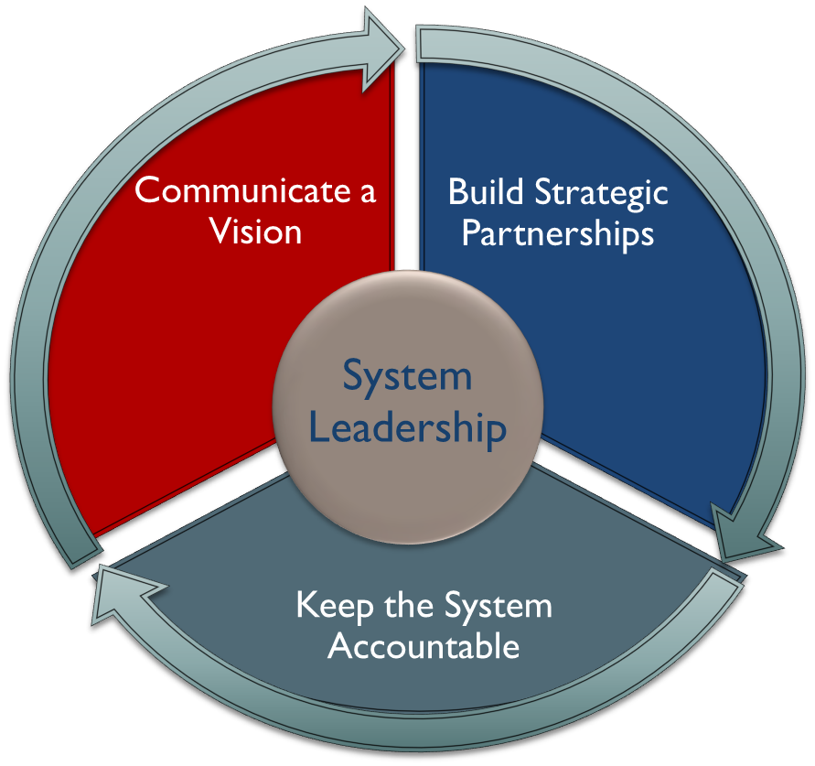

Describe the strategic partnerships of your board. Do you have all of the partnerships needed for a high-performing board? How might you strengthen and growth them?
Task | Responsible Person(s) | Timeline

Discuss how your board holds the system accountable. How might you improve accountability and ensure that measures drive desired outcomes?
Task | Responsible Person(s) | Timeline

Describe how you manage the work of the board. Do board members and staff work well together? Are roles clear? How might the board and staff work better together?
Task | Responsible Person(s) | Timeline

Consider how your board meetings are conducted, are they strategic and focused, are action items captured and followed up on, etc. How might meetings be more effective, and productive?
Task | Responsible Person(s) | Timeline

Consider how your board is engaged between meetings and in workgroups or taskforces. What works well? What could be done to make member engagement more effective, and productive?
Task | Responsible Person(s) | Timeline

A high performing board is strategic rather than tactical, consider what that means for your board. How does your board act, is it strategic or tactical? How might your board shift from tactical to strategic actions?

Task | Responsible Person(s) | Timeline

High performing board provide leadership to drive policy to practice, Sector Strategies are key in building a demand-drive workforce system. How might your board drive the development and sustainability of Sector Strategies?

Task | Responsible Person(s) | Timeline

High performing board provide leadership to drive policy to practice, Career Pathways are key in building a demand-drive workforce system. How might your board drive Career Pathways?

Task | Responsible Person(s) | Timeline

How might your board manage all of the opportunities discussed in this action planner, in a way that they are coordinated and align to advance your board and your system?
Task | Responsible Person(s) | Timeline

