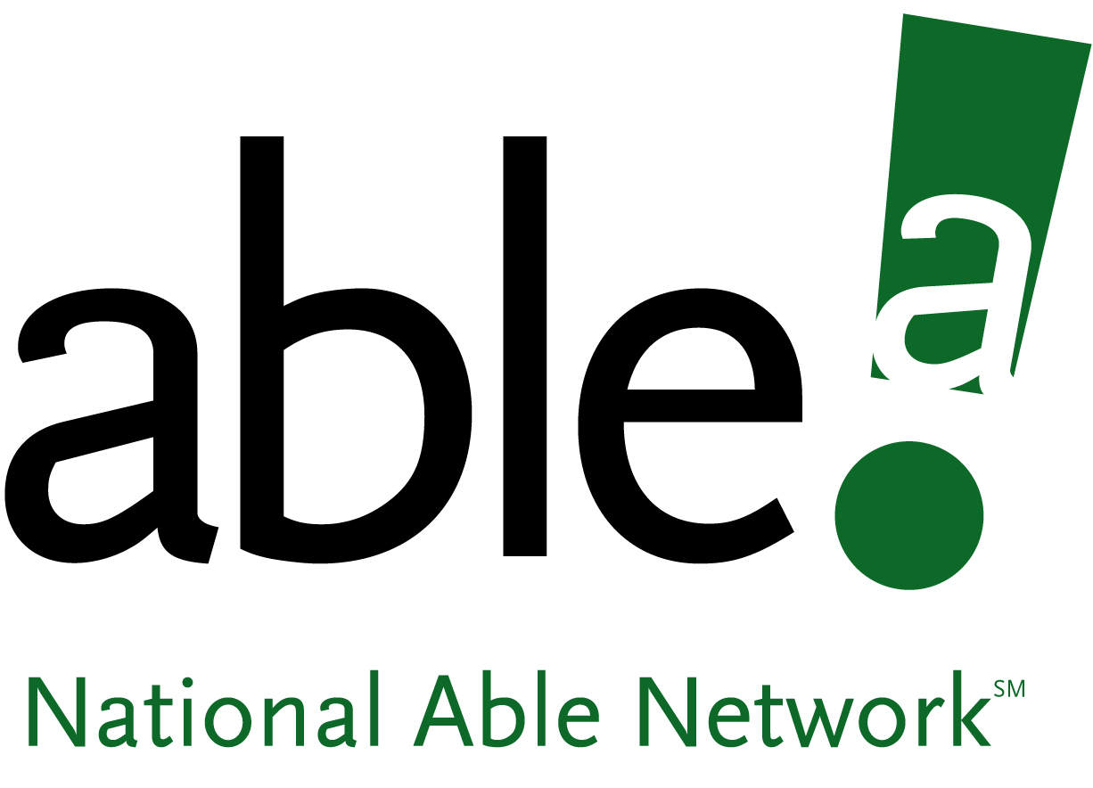  Dear_____________________________,  Are you missing out?  Did you know that even if currently employed,  you may still be eligible?  National Able Network® has been trying to contact you. Under the Trade Adjustment Assistance Reauthorization Act (TAARA), you may qualify for  - paid training  - wage subsidy  - individualized job search assistance  Please call us at 312-994-5569 and mention this TAARA notice.  We hope to hear from you soon!  ¿Habla español? Comuniquese con Nora al 312-994-8316. |  | Dear_____________________________,  Are you missing out?  Did you know that even if currently employed,  you may still be eligible?  National Able Network® has been trying to contact you. Under the Trade Adjustment Assistance Reauthorization Act (TAARA), you may qualify for  - paid training  - wage subsidy  - individualized job search assistance  Please call us at 312-994-5569 and mention this TAARA notice.  We hope to hear from you soon!  ¿Habla español? Comuniquese con Nora al 312-994-8316.
Dear_____________________________,  Are you missing out?  Did you know that even if currently employed,  you may still be eligible?  National Able Network® has been trying to contact you. Under the Trade Adjustment Assistance Reauthorization Act (TAARA), you may qualify for  - paid training  - wage subsidy  - individualized job search assistance  Please call us at 312-994-5569 and mention this TAARA notice.  We hope to hear from you soon!  ¿Habla español? Comuniquese con Nora al 312-994-8316. |  | Dear_____________________________,  Are you missing out?  Did you know that even if currently employed,  you may still be eligible?  National Able Network® has been trying to contact you. Under the Trade Adjustment Assistance Reauthorization Act (TAARA), you may qualify for  - paid training  - wage subsidy  - individualized job search assistance  Please call us at 312-994-5569 and mention this TAARA notice.  We hope to hear from you soon!  ¿Habla español? Comuniquese con Nora al 312-994-8316.
1700 W. 18th St.  Chicago, IL 60608  Customer Name  Address Line 1  Address Line 2  Are you missing out? |  | 1700 W. 18th St.  Chicago, IL 60608  Customer Name  Address Line 1  Address Line 2  Are you missing out?
Company Name: _________________________________  1700 W. 18th St.  Chicago, IL 60608  Customer Name  Address Line 1  Address Line 2  Are you missing out? |  | Company Name: _________________________________  1700 W. 18th St.  Chicago, IL 60608  Customer Name  Address Line 1  Address Line 2  Are you missing out?

Company Name: _________________________________ Company Name: _________________________________

