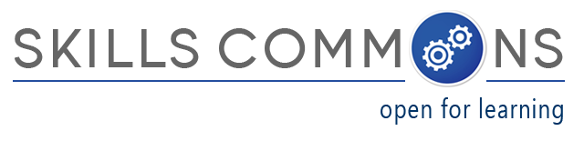
Showcase of OER “Derivative” Reuse
“OpenStax College OER Anatomy & Physiology Textbook.pdf”

The U.S. Department of Labor’s Trade Adjustment Assistance Community College and Career Training (TAACCCT) grant program has created an online library called SkillsCommons containing free and open learning materials and program support materials for job-driven workforce development. The Open Educational Resources (OER) are produced by community colleges across the nation and can be found, reused, revised, retained and redistributed by individuals, institutions, and industry.

SkillsCommons.org is designed and managed by the California State University and its MERLOT program for the U.S. Department of Labor’s TAACCCT grant program under a four-year cooperative agreement. If you are interested in the materials, the CSU-MERLOT dedicated team of librarians, educators, and developers are here to assist not only TAACCCT Grantees, but anyone who is using and reusing OER.

Here is an example of how students taking a Basic Human Biology Course were able to save $200-$300 on a textbook because a TAACCCT Grantee reused an OpenStax Textbook:

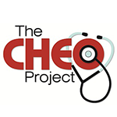
Project Name: “Consortium of Healthcare Education Online (CHEO)” (Round 2): https://www.skillscommons.org/handle/taaccct/43

Lead Institution: Pueblo Community College
Project Director: Maria Fieth, Pueblo Community College
email: mariafieth@gmail.com
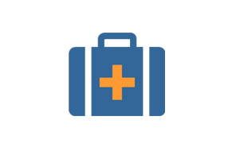
Project Goals: To develop or transition identified allied healthcare courses and programs into hybrid and/or online formats.

Strategy to Achieve Goals: Some of the programs will be new and others currently provided in the face-to-face format only, will offer students the opportunity to acquire stackable certificates, allowing them to make progress in their profession as working adults while pursuing academic credentials. CHEO partners will develop new lab exercises using the North American Network of Science Labs Online (NANSLO) labs to provide their students with the opportunity to conduct science experiments online.

Population Served: TAA eligible workers, returning veterans and other adults.

Areas Served: State: Alaska, Counties: Kodiak Island Borough, Cities: Kodiak; State: Colorado, Counties: Archuleta, Bent, Clear Creek, Crowley, Custer, Dolores, Fremont, Gilpin, Jefferson, La Plata, Montezuma, Otero, Park, Pueblo and San Juan, Cities: Arvada, Denver, La Junta, Lakewood, Pueblo; State: Montana, Counties: Cascade, Chouteau, Fergus, Flathead, Glacier, Hill, Judith Basin, Lewis & Clark, Liberty, Lincoln, Meagher, Pondera, Teton, Toole, Cities: Great Falls and Kalispell; State: South Dakota, Counties: All 66, but primarily: Beadle, Brookings, Brown, Campbell, Clark, Codington, Day, Deuel, Edmunds, Faulk, Grant, Hamlin, Hand, Hughes, Hyde, Kingsbury, Marshall, McPherson, Potter, Roberts, Spink, Sully and Walworth, Cities: Watertown; State: Wyoming; Counties: Laramie, Cities: Cheyenne.

OER reused: The OER reused was an openstax textbook:

“Anatomy and Physiology”: https://openstaxcollege.org/textbooks/anatomy-and-physiology

Derivative OER created:

“OpenStax College OER Anatomy & Physiology Textbook.pdf”: http://www.skillscommons.org/handle/taaccct/3442

Benefits of reuse: Students did not need to purchase a textbook for the course resulting in a savings of $200-$300 (based on similar texts)! Assurance of quality of the text as a result of it going through a standardized peer-review process. Developed by experts and updated with current revisions. Ability to adapt the text to fit needs of the current course.

