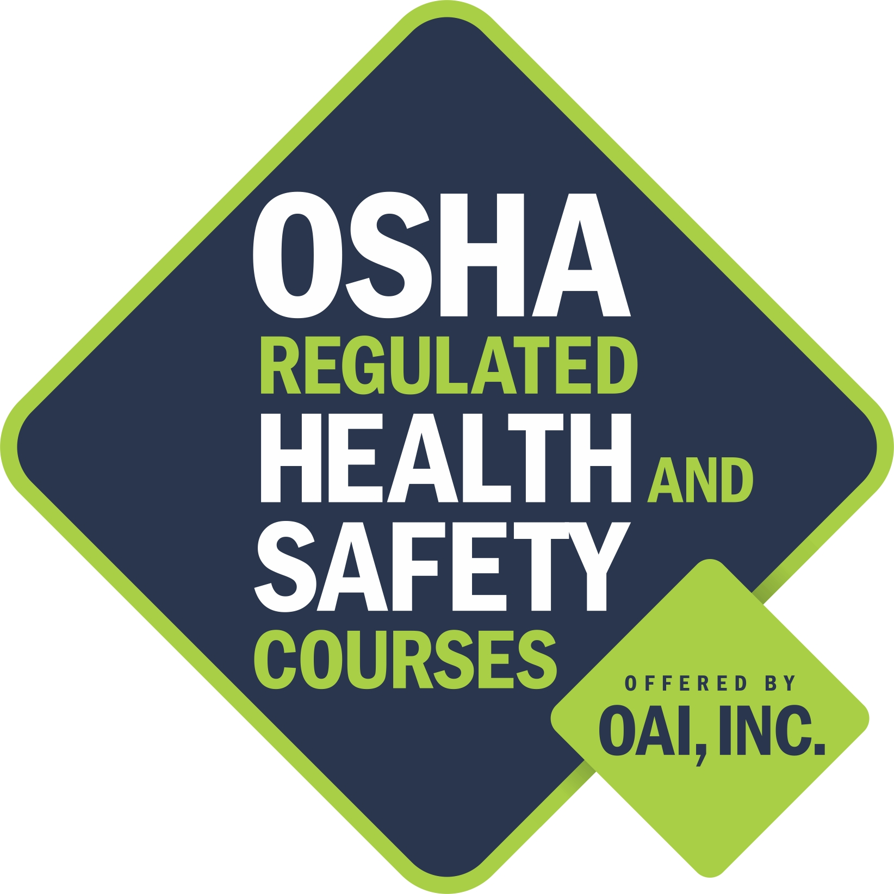

Memorandum of Understanding

between

OAI, inc

and

your program

OAI, inc., a Chicago-based non-profit training organization, agrees to leverage its Hazardous Waste Worker Training (HWWT) grant, funded by the National Institute of Environmental Health Sciences (NIEHS), to provide training and support as detailed in this Memorandum of Understanding (MOU).

Training Support: OSHA 510 and 500 – Basic Instructor Course in Occupational Safety and Health Standards for the Construction Industry

- OAI, inc, in partnership with YouthBuild USA, sponsorws OSHA 510 and 500 courses conducted by the Rocky Mountain Center for Occupational & Environmental Health, located in Sandy, Utah. The above courses were conducted September 30 – October 3, 2013 and October 4-8, 2013.

- Your Program training program, identified instructor _________ as eligible to attend the above mentioned classes. Following successful completion of these courses, _________ is qualified to teach the OSHA 10 and OSHA 30 Construction courses to___________ students.

- Mr/Ms___________ agrees to register each YouthBuild OSHA 10 Construction class on OAI’s website - www.oaitrainer.org. This allows instructors to notify OAI of requested OSHA 10 classes which will be subsidized pending OAI approval.

- For each OSHA 10 or 30 course that Mr.?Ms__________ conducts for ____________’ program (with a minimum of 12 YouthBuild students per class*), __program________ agrees to complete and electronically submit paperwork (see attached list) to OAI’s Technical Training Manager, Sanobeia Brima at OAIHwwt@gmail.com.
*if OSHA classes do not meet this minimum, please notify Sanobeia Brima prior to the beginning of the class to determine if OAI can provide subsidies

- Following completion of each OSHA 10 course, __your program___________ agrees to submit photocopies of each YouthBuild student’s OSHA-issued cards to OAI.

- Program name will submit an invoice to OAI within 30 days of training completion that reflects the total amount Program name paid for YouthBuild OSHA cards plus $50 dollars for completion of paperwork.
.

II. Term

The term of this agreement will begin on September 30, 2013 and end on July 31st, 2014.

In agreement, October 10, 2013:

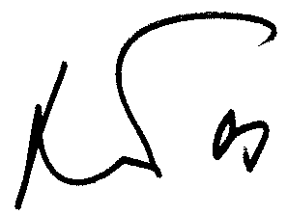
______________________________ __________________________________
Alexander Prentzas Authorized person
Director, Business + Worker Training
OAI, inc.
Chicago, Illinois

