February 2017
DEI Ticket Ambassadors
Highlights

DEI Ticket Ambassadors / Workforce EN

Community of Practice
This document includes highlights of the individuals that have been selected to represent their state/DEI project as a DEI Ticket Ambassador. The DEI Ticket Ambassadors have met or exceeded the following criteria:

- EN contract in good standing with SSA
- Security clearance in place, and access to the SSA secure portal
- At least 10 Tickets assigned
- Some Ticket holders currently working
- At least 2 Ticket holders in Outcome status
- Processed at least one Annual Performance Outcome Report (APOR)
- Preferred / not required – Understand SSA disability benefits and work incentives

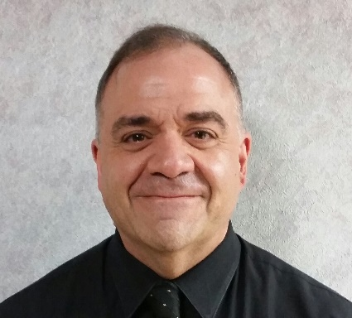
Requested information about Ambassador | Responses to the requests for information
Name: | Richard Berrena
Title: | Disability Resource Coordinator
Service area location(s): | Hampden County, Western Massachusetts
Phone: | (413) 858-2885
Email: | rberrena@futureworksjobs.org
EN Name: | FutureWorks Career Center
Total # Ticket holders served as of June 2016: | 50
Total # Ticket holders working as of June 2016: | 25
Milestone to Outcome Ratio: | 15:10 (M to O) = 40%
CWIC or Cornell Certification in SSA Disability benefits: | No
Area(s) of Expertise: | EN activities, job counseling and development, support services referrals, and interagency coordination
Population of the Area Being Served: | 467,319
Service Area: Urban, Suburban or Rural or Both: | Urban and Suburban
Major Industries in Your Area: | Health Care, Administrative, and Retail
Number of Job Centers Covered: | 1
# of Full-Time Staff located on-site in the Job Centers Covered: | 33
Top 3-5 Partners of the Workforce EN: | Massachusetts Rehabilitation Commission, Western Mass Employment Consortium, and DMH
Bio:
Since 2012 I have been the Disability Resource Coordinator under the Disability Employment Initiative Grant, where I have provided intensive core services for individuals with disabilities, collaborated with other agencies regarding best practices for providing services, and provided education/re-training via the DEI Grant. Prior to 2012, I worked under the Department of Revenue/Child Support Enforcement Grant, providing intensive core services for non-custodial fathers to secure employment, and met and exceeded goals of the Grant in both average hourly rate of pay and entered employments. Additionally I was the Disability Program Navigator, funded under DOL where I assisted individuals with disabilities to navigate through the Career Center System, by making appropriate referrals to agencies, and working as the Ticket To Work Social Security Program Representative, writing one of the first full-time Tickets.

Requested information about Ambassador | Responses to the requests for information
Name: | Susan Brenner
Title: | Training Specialist II
Service area location(s): | State of Alaska
Phone: | 907-269-4757
Email: | susan.brenner@alaska.gov
EN Name: | State of Alaska: Department of Labor and Workforce Development
Total # Ticket holders served as of June 2016: | 96
Total # Ticket holders working as of June 2016: | 53
Milestone to Outcome Ratio: | 109:229 (M to O) = 67.8%
CWIC or Cornell Certification in SSA Disability benefits: | n/a
Area(s) of Expertise: | AJCN/EN Activities  Administrative Support of Grant
Population of the Area Being Served: | 735,601
Service Area: Urban, Suburban or Rural or Both: | All
Major Industries in Your Area: | State/Federal Government, Fishing  Oil and Gas, Tourism, Mining
Number of Job Centers Covered: | 17
# of Full-Time Staff located on-site in the Job Centers Covered: | 82
Top 3-5 Partners of the Workforce EN: | AK Department of Vocational Rehabilitation, WIOA Adult and Youth Grantees, Governor’s Council on Disabilities and Special Education, AK Mental Health Trust Authority
Bio:
I have worked for the State of Alaska for 26+ years. I started working as an Eligibility Technician for Public Assistance and after 1.5 years and switched over to Department of Labor. I have worked my way up the ladder, so to speak, in all phases of the job center. I have been a member of the Employment and Technical Unit since 2002, working with a variety of programs, as well as writing policies and procedures for staff. I became the staff trainer in 2005 and began working with the Disability Employment Initiative Grant in 2012. I am responsible for the majority of the administrative duties (budgets, ticket assignments, payments, etc.) as well as staff training.

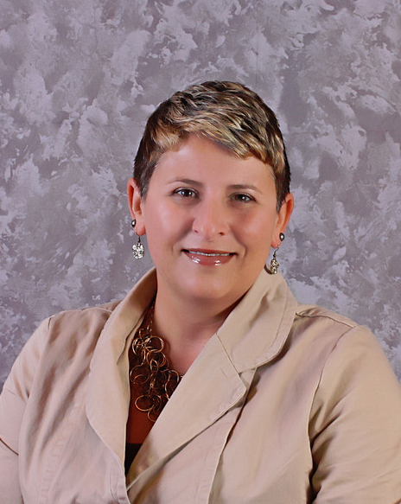
Requested information about Ambassador | Responses to the requests for information
Name: | Tera Brooks
Title: | Disability Resource Coordinator
Service area location(s): | Workforce Service Area 5  Central Minnesota  11 Counties
Phone: | (763)-710-0999
Email: | tbrooks@cmjts.org
EN Name: | Central MN Jobs & Training Services
Total # Ticket holders served as of June 2016: | 16
Total # Ticket holders working as of June 2016: | 12
Milestone to Outcome Ratio: | 38:1 (M to O)=2.6%
CWIC or Cornell Certification in SSA Disability benefits: | Yes
Area(s) of Expertise: | EN Administration, EN Payments and EN/AJC Services
Population of the Area Being Served: | 500,670
Service Area: Urban, Suburban or Rural or Both: | Rural
Major Industries in Your Area: | Healthcare, Manufacturing and Retail
Number of Job Centers Covered: | 11
# of Full-Time Staff located on-site in the Job Centers Covered: | 39
Top 3-5 Partners of the Workforce EN: | Adult Basic Education, Department of Employment and Economic Development (Job Services and Veteran Services) and Vocational Rehabilitation Services
Bio:
Tera Brooks has had the privilege of working with individuals with disabilities for over 15 years. She is very passionate about working with this population and believes in what “people can do” that matters. Tera is a Disability Resource Coordinator and assists with the facilitation of the Disability Employment Initiative and the Ticket to Work program at Central MN Jobs & Training Services. She enjoys helping participants reach their goals and become self- sufficient.

Requested information about Ambassador | Responses to the requests for information
Name: | Randall Cook
Title: | Disability Resource Coordinator (DRC)
Service area location(s): | Broome (Binghamton-Johnson City-Endicott) and Tioga (Owego) counties, NY
Phone: | 607-778-6478
Email: | rcook@co.broome.ny.us
EN Name: | NYESS – Broome-Tioga Workforce NY
Total # Ticket holders served as of June 2016: | 345
Total # Ticket holders working as of June 2016: | 34
Milestone to Outcome Ratio: | 31:14 (M to O) = 31.1%
CWIC or Cornell Certification in SSA Disability benefits: | Yes
Area(s) of Expertise: | EN/AJC Partnership  SSA disability benefits & work incentives  Other (job search assistance)
Population of the Area Being Served: | 246,020
Service Area: Urban, Suburban or Rural or Both: | Urban/Suburban
Major Industries in Your Area: | Healthcare, State & local gov’t., higher education, transportation/warehousing, electronics manufacturing
Number of Job Centers Covered: | 2
# of Full-Time Staff located on-site in the Job Centers Covered: | 23
Top 3-5 Partners of the Workforce EN: | Acces-VR, Achieve, Catholic Charities, Community Options,
Bio:
Randall Cook has served as DRC for Broome-Tioga Workforce New York since 2011 under the Round 1 DEI. Previously, he served in various supervisory positions with Workforce New York. He earned his Community Work Incentives Coordinator status through Virginia Commonwealth University in 2012, established an EN, and later joined a statewide EN (New York Employment Services System) in 2014. Mr. Cook has used his 20+ years in managing employment, training and customer service issues to provide direct services in job search and benefits advisement, integrating One-Stop services for individuals with disabilities, and building bridges with agencies serving persons with disabilities. He is a graduate of the Pennsylvania State University and lives in Binghamton, NY with his wife.

P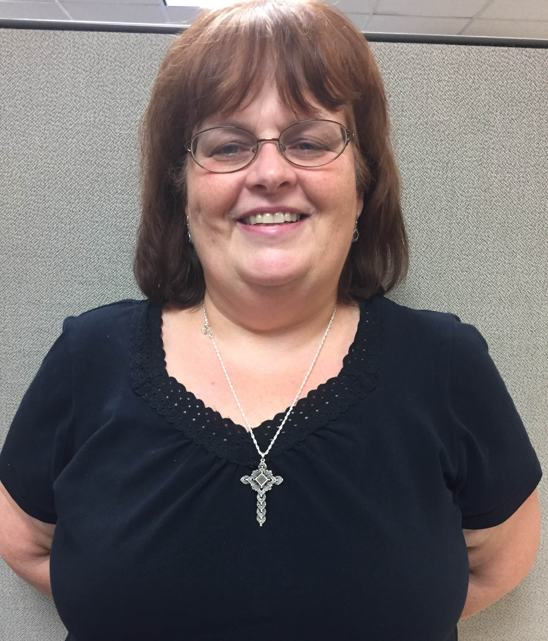
Requested information about Ambassador | Responses to the requests for information
Name: | Kathy DeAngelo
Title: | Disability Resource Coordinator
Service area location(s): | Otsego County, Delaware County, Chenango County, NY
Phone: | 607-432-4800 ext. 113
Email: | deangelok@otsegocounty.com
EN Name: | CDO Workforce/NYESS
Total # Ticket holders served as of June 2016: | 65
Total # Ticket holders working as of June 2016: | 39
Milestone to Outcome Ratio: | 41 %
CWIC or Cornell Certification in SSA Disability benefits: | yes
Area(s) of Expertise: | EN/AJC, SSA benefits & incentives, partnership plus
Population of the Area Being Served: | 157,000
Service Area: Urban, Suburban or Rural or Both: | Rural and suburban
Major Industries in Your Area: | Healthcare, Manufacturing, Education, Retail
Number of Job Centers Covered: | 4
# of Full-Time Staff located on-site in the Job Centers Covered: | 33
Top 3-5 Partners of the Workforce EN: | ACCES-VR, United Way, ARC Otsego
Bio:
Kathy DeAngelo is a Certified Benefits and Work Incentives Planner for CDO Workforce, providing advocacy for Social Security beneficiaries. She previously worked in positions for Otsego County, at the Department of Social Services and as a WIA Employment Counselor, cultivating a unique perspective that led to her successful role as DRC and Sr. Employment & Training Counselor. Far from her roots as a Brooklyn native and a Staten Island resident where she earned her Associates in Liberal Arts from the College of Staten Island, Kathy settled in Oneonta in 1985 to manage a deli which she owned for 6 years. She was hired by Otsego County DSS as a Social Welfare Examiner, determining eligibility for TANF and Food Stamps. It was when she began to understand the complexities of low-income households and how families with disabled adults often were trapped in a cycle of poverty. She transferred to become an Employment Counselor and she received training through a Cornell University Program and was awarded her Family Development Credential in 2002. The basis of this training was the belief that every person longs to be a contributing member of society and that human services workers need to focus on an individual’s strengths and support their dreams. During the past 9 years, Kathy has worked as a Disability professional, advocating and teaching individuals how to move from dreaming for a better life to taking the steps to make it happen. In this capacity, CDO Workforce has been one of the leading agencies in Round 1 DEI, in enrolling Ticket to Work participants, earning milestone payments and moving beneficiaries off of Social Security payments and into stronger financial stability.

Requested information about Ambassador | Responses to the requests for information
Name: | Kasia DeMauri
Title: | Project Advisor, CA Employment Development Department (EDD)
Service area location(s): | CA Counties of Placer, El Dorado, and Alpine (as DRC; 2011-2016 Golden Sierra Workforce EN)
Phone: | 916/654-7422 Desk
Email: | kasia.demauri@edd.ca.gov
EN Name: | Golden Sierra Job Training Agency
Total # Ticket holders served as of June 2016: | 35
Total # Ticket holders working as of June 2016: | 23
Milestone to Outcome Ratio: | 32:18 (M to O) = 36%
CWIC or Cornell Certification in SSA Disability benefits: | Yes
Area(s) of Expertise: | AJC/EN Activities, Outreach/Marketing, Coordinating and Leveraging resources with partners
Population of the Area Being Served: | 560,594 (over three counties)
Service Area: Urban, Suburban or Rural or Both: | Rural and Suburban
Major Industries in Your Area: | Local and State Government, Hospitality and Recreation, Healthcare, Retail, Technology
Number of Job Centers Covered: | 5
# of Full-Time Staff located on-site in the Job Centers Covered: | 15
Top 3-5 Partners of the Workforce EN: | CA Dept. of Rehabilitation, WIOA Service Providers, Local Businesses (OJT and Paid Work Experience)
Bio:
Kasia DeMauri is a State Project Advisor for the CA EDD. She holds a BA in Psychology from University of California at Berkeley and a MS in Human Resources Management from Golden Gate University. She served as DRC at Golden Sierra Job Training Agency EN for 5 years before beginning with EDD. During her tenure as a DRC, Kasia helped establish and market the EN. She also implemented and sustained the Service Delivery Strategies under the Round 2 DEI. Kasia worked simultaneously as the DRC regarding partner and community services as well as a WIOA Career Planner providing front-line individualized services to participants. Kasia’s achievements include establishing a system of concurrent service delivery with partners, developing paid Work Experience, increasing ticket re-assignment to the Workforce EN after successful DOR/VR case closure, and launching a peer-to-peer mentoring group. She is currently developing a presentation to encourage the statewide expansion of Workforce ENs and disability employment grant projects. Kasia lives in Auburn, California with her husband, son and two cats.
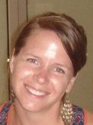
Requested information about Ambassador | Responses to the requests for information
Name: | Lauren Parker
Title: | Ticket to Work Program Director
Service area location(s): | Virginia, Maryland, DC
Phone: | (703) 752-1606
Email: | Lauren.parker@myskillsource.org
EN Name: | The SkillSource Group, Inc.
Total # Ticket holders served as of June 2016: | 231
Total # Ticket holders working as of June 2016: | 116
Milestone to Outcome Ratio: | 405:466 (M to O) = 53.5%
CWIC or Cornell Certification in SSA Disability benefits: | Yes
Area(s) of Expertise: | SSA work incentives, EN administration, Other: Establishing partnerships and service coordination
Population of the Area Being Served: | - Workforce Area: 1.9 million – covering 3 counties and 4 independent cities  - EN Area: 14.960 million
Service Area: Urban, Suburban or Rural or Both: | - Workforce Area: Suburban  - EN Area: Urban, Suburban and Rural
Major Industries in Your Area: | Workforce Area: IT, Healthcare, Hospitality, Construction
Number of Job Centers Covered: | 6
# of Full-Time Staff located on-site in the Job Centers Covered: | 32
Top 3-5 Partners of the Workforce EN: | WIOA Service Providers, Community Partners, VA Dept. for Aging & Rehabilitation (DARS/VR)
Bio:
Lauren Parker is Ticket Program Director at The SkillSource Group, nonprofit arm of Northern Virginia WDB. Initially tasked with implementing Ticket as a part-time consultant, Lauren quickly developed it into the top performing Workforce EN in the State. As a Round 1 DEI control site, she communicated EN activities with the state lead and served as a partner and resource to DRCs. Achievements include establishing in-house expertise on Social Security work incentives; design and delivery of disability training; and developing systems to integrate TTW within One-Stops. Lauren holds a BA in International Affairs from James Madison University. Prior to her TTW role, she ran a summer youth employment program for TANF recipients at the Fairfax County Department of Family Services and before workforce development, Lauren worked abroad for International House World Organization schools in Poland and South Africa and completed graduate coursework in the Netherlands. She is currently facilitating a new workforce board disability subcommittee and is working on strategies to change policy at the local, state, and federal levels around the treatment of SSDI under the WIOA adult program.

Requested information about Ambassador | Responses to the requests for information
Name: | Windy Swearingin
Title: | Project Coordinator, AK Department of Labor and Workforce Development
Service area location(s): | State of Alaska
Phone: | 907-465-2964
Email: | windy.swearingin@alaska.gov
EN Name: | State of Alaska Department of Labor and Workforce Development
Total # Ticket holders served as of June 2016: | 96
Total # Ticket holders working as of June 2016: | 53
Milestone to Outcome Ratio: | 109:229 (M to O) = 67.8%
CWIC or Cornell Certification in SSA Disability benefits: | In process
Area(s) of Expertise: | Blending and braiding funds, AJC/EN Activities, Partnering with other agencies, IRT model
Population of the Area Being Served: | 735,601
Service Area: Urban, Suburban or Rural or Both: | Urban, Suburban, Rural, Villages
Major Industries in Your Area: | State Government, Fishing, Oil and Gas, Tourism, Mining
Number of Job Centers Covered: | 18
# of Full-Time Staff located on-site in the Job Centers Covered: | 82
Top 3-5 Partners of the Workforce EN: | AK Department of Vocational Rehabilitation, WIOA Adult and Youth Grantees, Governor’s Council on Disabilities and Special Education, AK Mental Health Trust Authority
Bio:
Windy Swearingin is the AK DEI Project Coordinator for the Department of Labor and Workforce Development. She holds a Dual BS in Elementary and Special Education from Northern Arizona University and a MS in Professional Counseling from Grand Canyon University. She came from education to work as an AK DEI DRC II two years ago. In the time she has been with the Alaska EN system, Windy’s focus has been on partnering with other agencies and building IRTs. She has partnered with WIOA adult and youth grantees, Juvenile Justice, and AK VR to provide wrap around services. Recently Windy was promoted to Program Coordinator where she has begun establishing a cross-categorical system of change for ticket holders throughout the state system. A primary focus is to expand the EN in the AJC from 6 to 10 throughout the state. Windy will also be working with management and partnering agencies to continue to embed the Service Delivery Strategies for sustainability under the DEI Round IV.

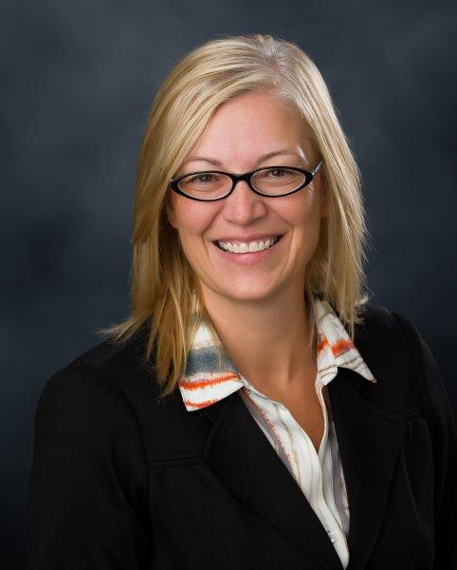
Requested information about Ambassador | Responses to the requests for information
Name: | Leslie Wojtowicz
Title: | Development Manager
Service area location(s): | Workforce Service Area 5  Central Minnesota  11 Counties
Phone: | (763)-271-3757
Email: | lwojtowicz@cmjts.org
EN Name: | Central MN Jobs & Training Services
Total # Ticket holders served as of June 2016: | 16
Total # Ticket holders working as of June 2016: | 12
Milestone to Outcome Ratio: | 38:1 (M to O) = 2.6%
CWIC or Cornell Certification in SSA Disability benefits: | No
Area(s) of Expertise: | EN Administration, EN Payments and EN/AJC Services
Population of the Area Being Served: | 500,670
Service Area: Urban, Suburban or Rural or Both: | Rural
Major Industries in Your Area: | Healthcare, Manufacturing and Retail
Number of Job Centers Covered: | 11
# of Full-Time Staff located on-site in the Job Centers Covered: | 39
Top 3-5 Partners of the Workforce EN: | Adult Basic Education, Department of Employment and Economic Development (Job Services and Veteran Services) and Vocational Rehabilitation Services
Bio:
Leslie Wojtowicz has been with Central MN Jobs & Training Services for 19 years. Throughout this time she has held a variety of positions within the agency. Leslie currently supports the corporation by growing and maintaining business and community partnerships. She also develops new funding streams to complement existing funding streams through grant writing and fund development initiatives. Under Leslie’s leadership CMJTS has become a successful Employment Network.

Requested information about Ambassador | Responses to the requests for information
Name: | Kathleen Hounsell
Title: | Ticket to Work State Lead
Service area location(s): | State of Maine
Phone: | (207) 623-7999
Email: | Kathleen.b.hounsell@maine.gov
EN Name: | MDOL-Bureau of Employment Services (BES)
Total # Ticket holders served as of June 2016: | 166
Total # Ticket holders working as of June 2016: | 70
Milestone to Outcome Ratio: | 52%
CWIC or Cornell Certification in SSA Disability benefits: | Yes
Area(s) of Expertise: | - SSA benefits Counseling (CWIC)  - Facilitate workshops for SSA beneficiaries (and staff)  - Training of TTW Liaisons in Job Centers
Population of the Area Being Served: | 1,293,000
Service Area: Urban, Suburban or Rural or Both: | Both
Major Industries in Your Area: | Tourism, Retail, healthcare, agriculture, ship building
Number of Job Centers Covered: | 12
# of Full-Time Staff located on-site in the Job Centers Covered: | 70
Top 3-5 Partners of the Workforce EN: | VR, WIOA providers, WIPA staff, Disability Rights Maine
Bio:
Kathy Hounsell has been the Ticket to Work State Lead in Maine since 2009, having previously worked for the State in both Unemployment and CareerCenter Services. She is responsible for facilitating both internal and external training for her colleagues and customers about the Ticket to Work Program and for growing the MDOL Bureau of Employment Services (BES)’s Employment Network. Kathy’s role for the State has traditionally been under a DEI Grant, Round 1 and Round 4, which concluded on 1/31/17. She now has the unique responsibility and challenge of guiding the Agency’s Employment Network to continued success and sustainability “post DEI Grant”.

