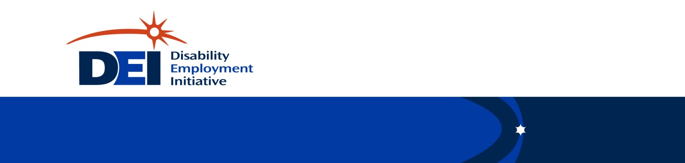

DEI and Career Pathways Functional Alignment
WIOA Title 1 State Level
April 2018

Disability Employment Initiative (DEI)

Career Pathways Functional Alignment Questions and Actions

WIOA Title 1 State Level

(Note: WIOA Title I State Level under DEI is considered to be the State Level Workforce Board that determines policy and distributes funds to the Regional Level/Workforce Boards. The Regions then go through the same process at the Local Level.)

WIOA TITLE 1 STATE LEVEL
BEGINNER – Investigation, Finding Out What Exists
Questions
- What does the WIOA state plan indicate related to career pathways implementation and apprenticeship?
  - What, if any, specifics are included related to including job seekers with disabilities?
Notes:

- What state initiatives are currently in place, or in the works, regarding labor/employment?
  - What, if any, specifics are included related to including job seekers with disabilities?
Notes:

- Who is the contact for your state’s Apprenticeship Office?
  - What is the role, if any that the Apprenticeship Office plays with the WIOA plan?
  - What activities does the Apprenticeship Office include that promote and support apprenticeship opportunities for job seekers with disabilities?
Notes:

- Who are the stakeholders that develop the state’s WIOA plan?
  - How involved are disability partners in this activity?
Notes:

- What does your DEI Work Plan indicate in terms of activities at the state level?
  - How is your DEI Project leadership and/or partners currently engaged in state level activities related to Career Pathways?
  - How is your DEI Project leadership and/or partners currently engaged in state level activities related to Apprenticeship Programs?
  - What additional relationships are outlined in your plan with other partners at the state level that are engaged in Career Pathways implementation?
Notes:

INTERMEDIATE – Problem-Solving and Engagement
Activities/Directives
- Bring together state level leadership among partners and Career Pathways programs and regularly convene this partner group in order to support the local sites partner engagement and activities and extrapolate the lessons learned from these local sites for application across the workforce system and its partners across the state.
Notes:

- Identify opportunities for DEI Project Leadership activities to connect and support Career Pathways implementation.
  - At the local level
  - At the regional level
  - At the state level
Notes:

- Identify additional funding sources that can be used or pursued at the state level to leverage and sustain DEI practices related to Career Pathways and DRC positions beyond the life of the DEI grant funding, in addition to or in place of Ticket Revenue from Workforce ENs.
Notes:

- Identify examples of successful regional level strategies at the local level that can be replicated (through agreements or shared efforts and procedures) across the state to increase the amount and/or effectiveness of outreach to educate and encourage jobseekers with disability to access Career Pathways trainings.
Notes:

- Identify policy changes at the state level to address programmatic and procedural barriers and promote and support successful inclusion of job seekers with disabilities at the local and regional level within Career Pathways programs.
Notes:

ADVANCED – Sustainability and Expansion of Systems Impact
Outcomes
- Use the information and best practices from the DEI that have been recognized as increasing access to Career Pathways for customers with disability/and-or/multiple barriers to employment by the state leadership partners to inform and develop future workforce policy and procedure.
Notes:

- Create a guide/manual that supports inclusive Career Pathway implementation that provides guidance and directives to workforce at the local, regional, and state levels.
Notes:

- Ensure that possible funding sources that can sustain DEI practices related to Career Pathways and DRC positions beyond the life of the DEI grant funding have been committed to being utilized in this way.
Notes:

- Market successful strategies found at the local and regional levels throughout the state in order to educate and encourage job seekers with disabilities in accessing Career Pathway programs.
Notes:

- Identify opportunities for future collaborations or Projects that support inclusive Career Pathways and include DEI strategies.
Notes:

