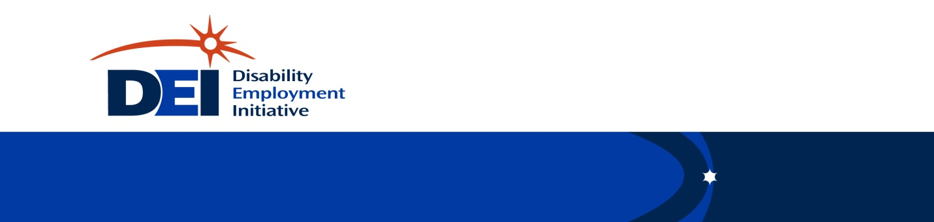

DEI and Career Pathways Functional Alignment
WIOA Title 1 Regional Level
April 2018

Disability Employment Initiative (DEI)

Career Pathways Functional Alignment Questions and Actions

WIOA Title 1 Regional Level

(Note: WIOA Title I Regional Level under DEI is considered to be the entity contracting with the agencies that provide Title I services to the local level workforce board. They oversee the local/center level contracts – they are “the funder”.)

WIOA TITLE 1 REGIONAL LEVEL
BEGINNER – Investigation, Finding Out What Exists
Questions
- What Career Pathways Programs Exist Regionally? And how often are WIOA customers engaged in these programs?
Notes:

- Are any individual job centers or partners in DEI pilot regions connecting jobseekers to Career Pathways trainings at a high level, and if so do these customers achieve the outcomes associated with those trainings?
Notes:

- Are any individual Job centers or partners in DEI pilot regions serving a high percentage of jobseekers with disabilities, or focusing on a demographic that contains a high percentage of customers with disabilities?
Notes:

- What are the regional efforts going on around identifying and developing new or modifying existing Career Pathways programs in order to comply with the State’s WIOA plan?
Notes:

- Which regional Partners (WIOA Core and otherwise) are involved in the regional Career Pathways development efforts and which partners with a stake in the outcome are not currently engaged?
Notes:

INTERMEDIATE – Problem-Solving and Engagement
Activities/Directives
- Identify examples of successful customer level strategies at the local level that can be piloted (through agreements or shared efforts and procedures) at the regional level to increase the amount and/or effectiveness of outreach to educate and encourage jobseekers with disability to access Career Pathways trainings.
Notes:

- Flag successful center level strategies that can be Piloted (through agreements or shared efforts and procedures) to highlight how DEI service delivery strategies can be used to increase access to career pathways trainings for customers with disabilities regionally.
Notes:

- Leverage regional partnerships to support a jobseekers with disabilities access Career Pathways trainings.
Notes:

- Apply DEI service strategies that have resulted in outcomes to support the regional efforts going on around identifying and developing new or modifying existing Career Pathways programs.
Notes:

- Use DEI outcomes to inform and enhance regional efforts to comply with the WIOA state plan by identifying and developing new or modifying existing Career Pathways programs.
Notes:

ADVANCED – Sustainability and Expansion of Systems Impact
Outcomes
- Systemize successful examples of customer level strategies that have been demonstrated at the local level (through agreements or shared efforts and procedures) that increase the amount and/or effectiveness of outreach to educate and encourage jobseekers with disability to access Career Pathways trainings.
Notes:

- Standardize successful center level strategies that can be implemented regionally (through agreements or shared efforts and procedures) that increase access to career pathways trainings for customers with disabilities in order to sustain DEI service delivery strategies post project funding.
Notes:

- Use successful outcomes obtained through customer level resource leveraging and regional pilots to develop outcome based MOU’s that support jobseekers with disabilities to access Career Pathways trainings.
Notes:

- Standardize DEI service strategies that have resulted in outcomes to support the regional efforts going on around identifying and developing new or modifying existing Career Pathways programs region wide.
Notes:

- Provide strategies and resources found in the successful outcomes provided by utilizing DEI strategies in Career Pathway programs to regional leadership in order to comply with the WIOA state plan.
Notes:

