Apprenticeship Expansion Acceleration Strategies: Action PLANNING TOOL
This Action Planning Tool is meant to help state apprenticeship teams review the quick win and acceleration strategies outlined in the Apprenticeship Expansion Acceleration Strategies Resource, identify strategies that may work in their states, and plan and document next steps. You will find instructions in the header and an example at the top of the chart.
For ease of use, we include all quick-win and acceleration strategies from the accompanying resource in column 1 (Quick-Win and Acceleration Strategies). We encourage apprenticeship expansion teams to begin by reviewing these strategies and deleting those that are not relevant or already part of your work. Teams can then work together to explore the remaining relevant strategies and identify the resources required for implementation. Next, they can establish priorities—perhaps starting with a few that are either high impact or quick wins (or both)—and outline some concrete next steps. States may wish to review and discuss this together as a team—as part of a brainstorming and strategy session—or have team members fill this out individually for later discussion. They may also want to distribute this tool to associated partners and schedule time to discuss viable strategies.
Quick-Win and Acceleration Strategies | How might this strategy be implemented here?  Rephrase the general strategy as needed to describe what may work in the context of your state. List sub-strategies, key implementation milestones, and associated needs. | Resources/Adjustments Required  Ex: staffing, partnerships, policy change, funding, partnership alignment, etc. | Priority  Evaluate as high, medium, or low based on impact and/or ease of implementation. | Next Steps  Bulleted next steps, responsible parties, and timelines
EXAMPLE  1g. Reevaluate and adjust budgets based on performance | Re-evaluate current subgrantee allocations based on chance of success and target new subgrant awards based on feasibility scoring | Funding adjustment, staffing time | High | Grant manager reviews grantee reports and plans to identify those meeting performance goals and those underperforming, and proposes adjustments by January 14, 2022
1a. Tap into economic and pandemic recovery funds that align with talent development and apprenticeship
1b. Tie grant expenditures to federal workforce funding streams with a short timeframe for expenditure
1c. Create incentives that encourage quick program registration and apprentice onboarding
1d. Look for and recruit influential, highly visible leaders (or those who can influence them)
1e. Spotlight successes and leverage peer leaders’ voices
1f. Partner and/or braid funding with another funding source that has infrastructure in place to move quickly
1g. Reevaluate and adjust budgets based on performance
1h. Create tools that promote alignment with and braiding of other existing funding sources

Quick-Win and Acceleration Strategies | How might this strategy be implemented here?  Rephrase the general strategy as needed to describe what may work in the context of your state. List sub-strategies, key implementation milestones, and associated needs. | Resources/Adjustments Required  Ex: staffing, partnerships, policy change, funding, partnership alignment, etc. | Priority  Evaluate as high, medium, or low based on level of impact. | Next Steps  Bulleted next steps, responsible parties, and timelines
2a. Conduct outreach to inactive sponsors and active sponsors with no apprentices
2b. Target active sponsors for additional programs and occupations
2c. Increase cohort sizes by targeting large employers and employer consortia
2d. Leverage labor market information expertise to understand shifting skill needs
2e. Pursue employers who already use work-based learning models
2f. Utilize employer champions to address myths and business misperceptions
2g. Reconsider how you frame Registered Apprenticeship as a talent pipeline strategy
2h. Expand your employer reach through traditional, online, and social media marketing

Quick-Win and Acceleration Strategies | How might this strategy be implemented here?  Rephrase the general strategy as needed to describe what may work in the context of your state. List sub-strategies, key implementation milestones, and associated needs. | Resources/Adjustments Required  Ex: staffing, partnerships, policy change, funding, partnership alignment, etc. | Priority  Evaluate as high, medium, or low based on level of impact. | Next Steps  Bulleted next steps, responsible parties, and timelines
3a. Make sure to capture all “reportable individuals”
3b. Leverage National Industry Intermediaries funded by USDOL
3c. Increase cohort sizes by working with other industry intermediaries
3d. Speed up standards development and approval times
3e. Lay the groundwork to enhance your partnerships

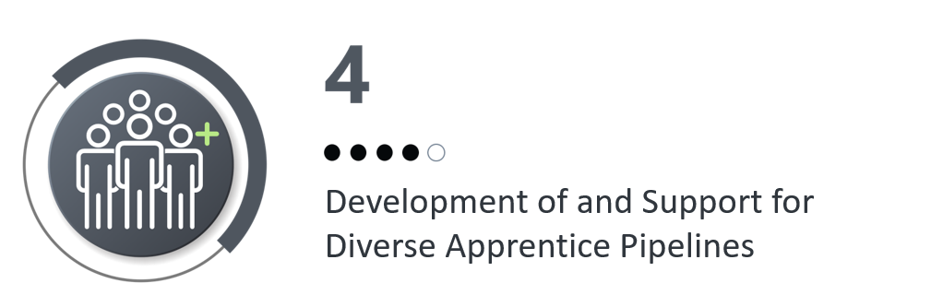  Quick-Win and Acceleration Strategies | How might this strategy be implemented here?  Rephrase the general strategy as needed to describe what may work in the context of your state. List sub-strategies, key implementation milestones, and associated needs. | Resources/Adjustments Required  Ex: staffing, partnerships, policy change, funding, partnership alignment, etc. | Priority  Evaluate as high, medium, or low based on level of impact. | Next Steps  Bulleted next steps, responsible parties, and timelines
4a. Target outreach to employers who have expressed a desire to expand diversity and/or target a particular population
4b. Review public-facing materials, and make them more inclusive and accessible
4c. Look for ways to partner with those already working with diverse populations of apprentices
4d. Identify and build on programs that serve specific target or diverse populations
4e. Create policies to define, support, and recognize quality pre-apprenticeship programs and build pathways to Registered Apprenticeship
4f. Map out roles and referral and/or co-enrollment processes with critical workforce partners who work with diverse populations
4g. Incorporate strategies for supporting a diverse workforce in your support to sponsors

Quick-Win and Acceleration Strategies | How might this strategy be implemented here?  Rephrase the general strategy as needed to describe what may work in the context of your state. List sub-strategies, key implementation milestones, and associated needs. | Resources/Adjustments Required  Ex: staffing, partnerships, policy change, funding, partnership alignment, etc. | Priority  Evaluate as high, medium, or low based on level of impact. | Next Steps  Bulleted next steps, responsible parties, and timelines
5a. Identify and start with the easiest paths to enhancing alignment between existing career and technical education (CTE) programs and Registered Apprenticeship
5b. Create tools to simplify apprenticeship expansion for educational partners
5c. Look for education partners with strong relationships in the community, trust from school districts, and established work-based learning models
5d. Leverage the capacity and expertise of community and technical college partners to serve as a connection point with both industry and apprentices
5e. Align with the Expanding Community College Apprenticeships (ECCA) initiative and other USDOL-funded investments in community and technical colleges

