H-1B SWFI Community of Practice (CoP) Registration Walkthrough
To register for the H-1B SWFI CoP and receive e-lerts when resources are posted, follow these steps:

- Go to https://www.workforcegps.org/ and sign in using your Username and Password. If you do not yet have a Username or Password, click the “Join Now!” link just below.

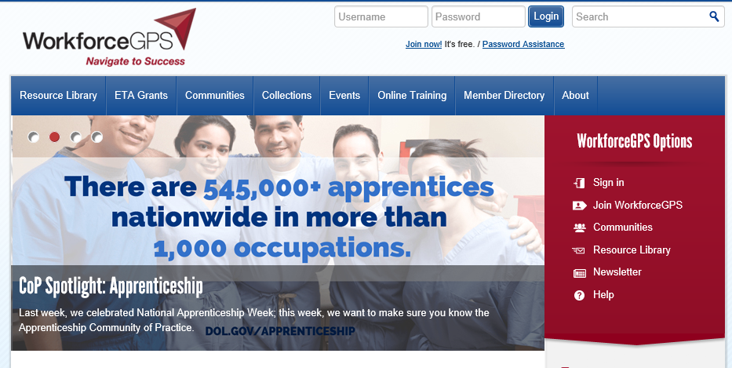

- Click on your hyperlinked name to access your Workforce GPS Profile.
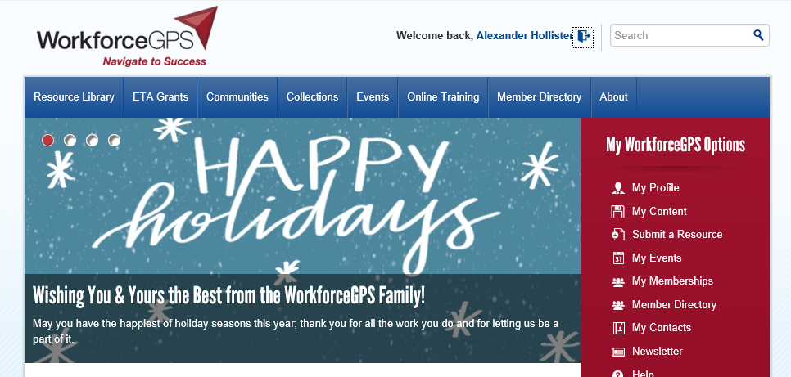

- Click on the “My Memberships and Notifications” tab, and then, under the “Communities” section, select the “H-1B Strengthening Working Families Initiative” box, as well as the boxes for any other CoP communities you would like to join. You should then begin receiving e-lerts from the CoP for the selected communities. Also, be sure to check the “I want updates on this community” box to ensure you receive all updates related to the H-1B SWFI CoP.

