United States Department of Labor

Employment & Training Administration (ETA)



*American Apprenticeship Initiative (AAI) Grants Quarterly Performance Results (QPR) System*

Quick Reference Guide



**AAI QPR Review Steps**

**AAI-QPR Overview**

The AAI grantees have pledged to train and hire more than 34,000 new apprentices in high-growth and high-tech industries including health care, IT and advanced manufacturing over the next five years. Grantees will enter participant data into Appian Quarterly Reporting System (AQRS), which will produce the Quarterly Performance Report (QPR) to adhere to DOL reporting requirements.

These are the steps for generating the QPR in the AQRS:

* Grantee uploads their QPR data
* QRS checks QPR data for errors and identifies any errors

found

* QRS generates QPR report using performance data

uploaded

* Grantee views their QPR and certifies it for accuracy
* Reviewer checks the QPR and provides comments, if

required

# WEB LINK

<https://dol.appiancloud.com/suite/sites/oa-qpr>

# How to access the system

* + - 1. Navigate the browser to <https://dol.appiancloud.com/suite/sites/oa-qpr>
      2. If this is the first time logging in, create a new password, and click the QPR link on the next page:

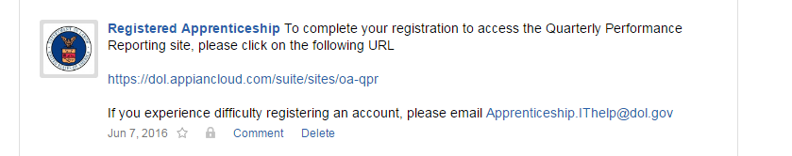

# Updating password

1. Navigate the browser to <https://dol.appiancloud.com/suite/>
2. On the login page, click the ‘Reset Your Password’ link

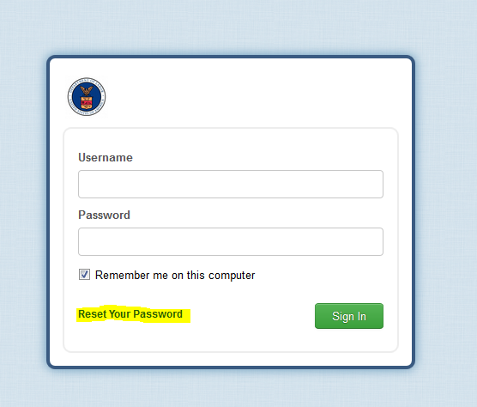

1. Enter your username on the next page and click the ‘Request Password Reset’ button

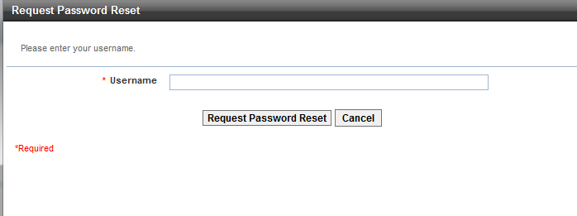

1. The system will then generate and email a temporary password.
2. Login to the system using this new temporary password.
3. On the next page, enter the temporary password as the ‘Old Password’ and choose a new password.

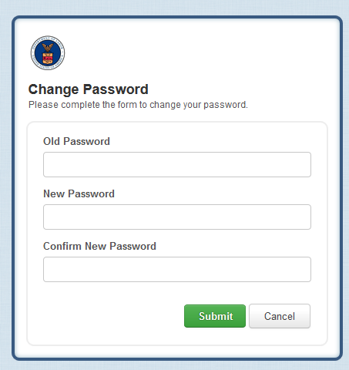

1. Click Submit to save your new password and login to the system

# Managing Accounts (adding, deleting, updating)

For Grantees:

Navigate to the “Manage User Accounts” tab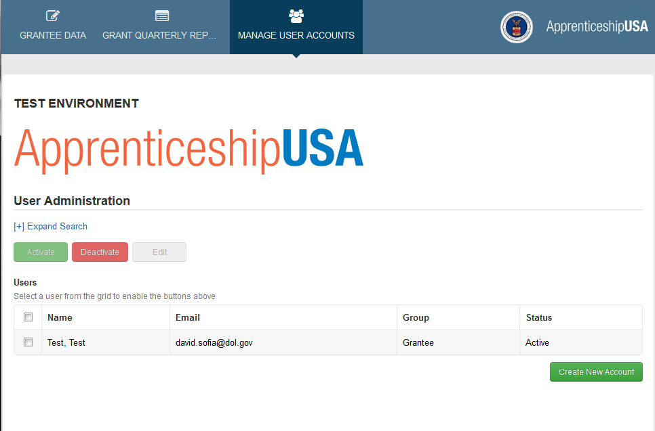

## Add a new account

* + - 1. Click the ‘Create New Account’ Button

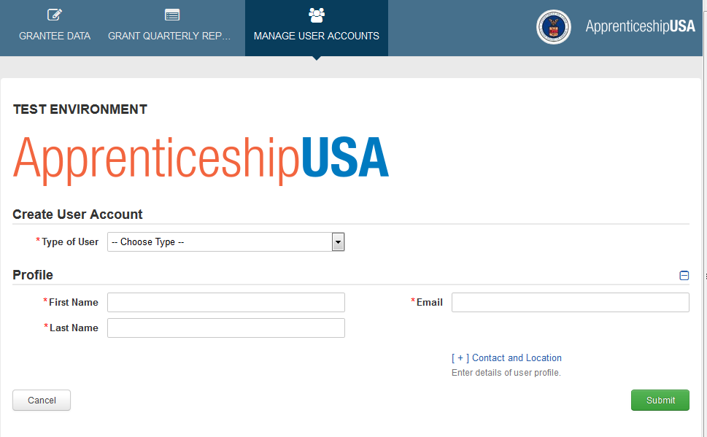

* + - 1. On the ‘Create User Account’ page, choose the type of user

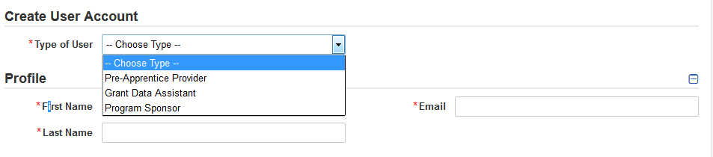

1. **Pre-Apprentice Provider** 
   1. Pre-Apprentice Provider users are only able to view/update their associated provider and the pre-apprentices associated with that provider

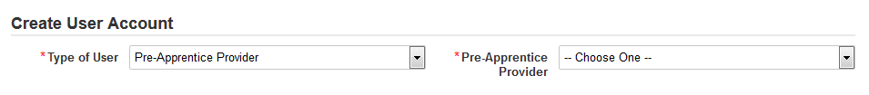

1. **Grant Data Assistant**
   1. Grant Data Assistant users can input data on all providers, programs, apprentices and pre-apprentices
2. **Program Sponsor**

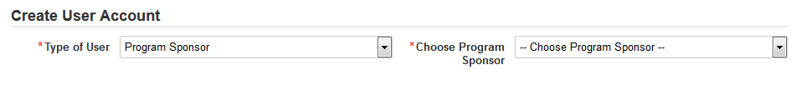

* 1. Program Sponsor users are only able to view/update their associated Program Sponsor and the Apprentices associated with that Provider
     + 1. Enter the rest of the required data and click the ‘Submit’ button

## Update Account

Select the account that needs to be updated:

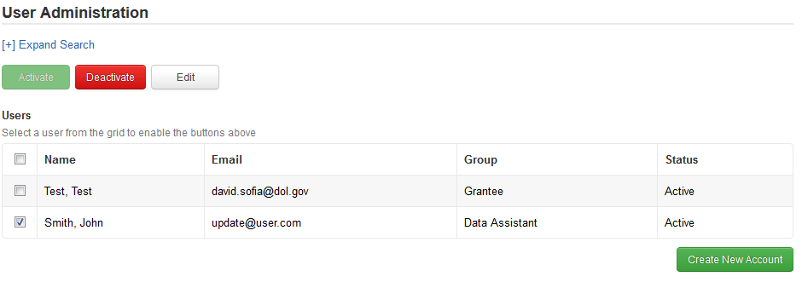

Click the ‘Edit’ button

**Note:** The email address cannot be updated, since it is the login username. If the email address is updated, a new account will have to be created, and the old one deactivated.

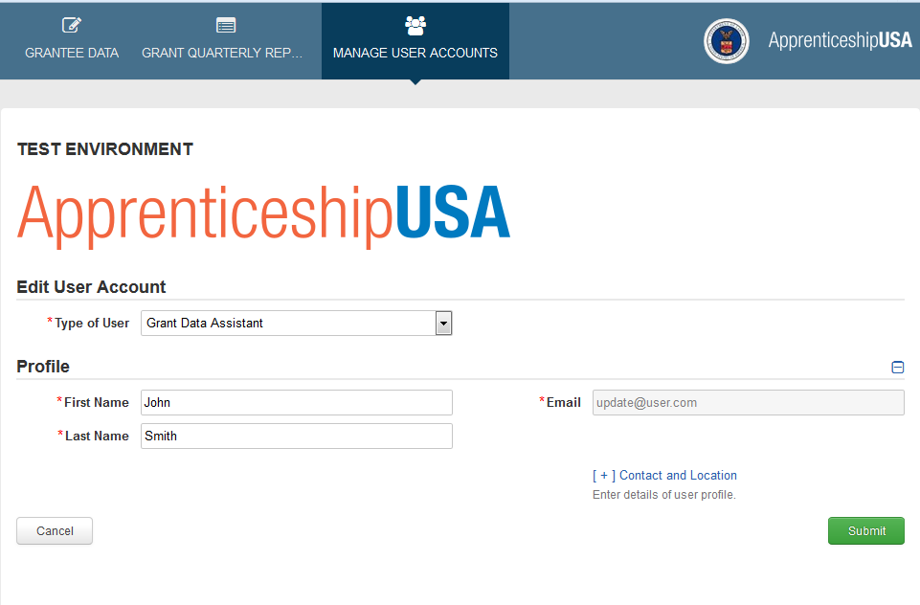

Click the ‘Submit’ button to save the updated user

## Deactivate Account

1. Select the account that needs to be ‘deactivated’
2. Click the ‘Deactivate’ button

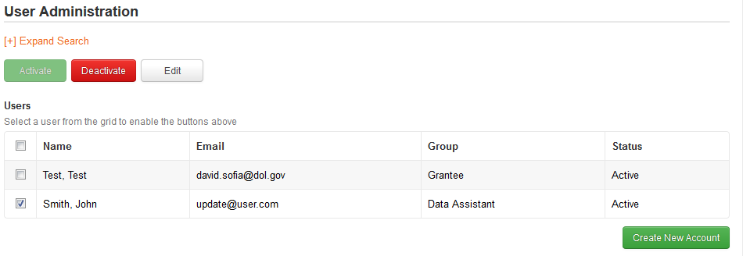

1. The user is now deactivated and will no longer be able to access the system.

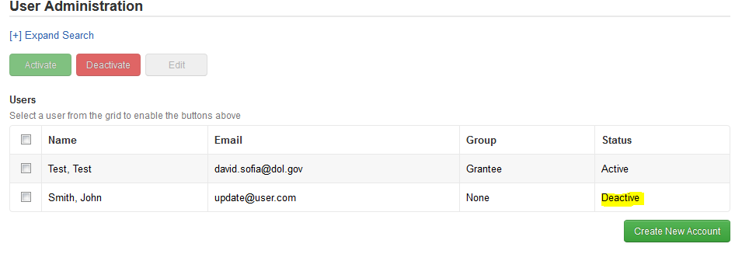

1. The user can be reactivated by selecting the user’s row and clicking the ‘Activate’ button

